**COMPARISON OF THE TEMPERATURE DISTRIBUTION OF A CYLINDRICAL AND SPHERICAL REACTOR USING PYTHON PROGRAMMING**

**A PROJECT REPORT**

***SUBMITTED BY***

**VYAAS VALSARAJ**

**DINESHASHALINI**

***in partial fulfilment for the award of the degree***

***of***

**BACHELOR IN TECHNOLOGY**

***in***

**CHEMICAL ENGINEERING**

**SRI SIVASUBRAMANIYA NADAR COLLEGE OF ENGINEERING**

(An Autonomous Institution, Affiliated to Anna University)

**ANNA UNIVERSITY: CHENNAI 600 025**

APRIL 2021

**ANNA UNIVERSITY: CHENNAI 600 025**

**BONAFIDE CERTIFICATE**

Certified that this project report “ **COMPARISON OF THE THERMAL**

**DISTRIBUTION AND HEAT LOSS OF A CONVENTIONAL AND**

**ROTATING SPHERICAL REACTOR USING MATHEMATICAL**

**MODELLING** ” is the bonafide work of “ **VYAAS VALSARAJ AND**

**DINESHA SHALINI** ” who carried out the project work under my supervision.

SIGNATURE SIGNATURE

Dr. R. Parthiban Dr. K. Jagannathan

HEAD OF DEPARTMENT SUPERVISOR

Professor Associate Professor

CHEMICAL ENGINEERING CHEMICAL ENGINEERING

SSN College of Engineering, SSN College of Engineering,

Rajiv Gandhi Salai (OMR) Rajiv Gandhi Salai (OMR)

Kalavakkam-603 110 Kalavakkam-603 110

Chennai Chennai

Submitted for the examination held on 5/8/2020 .

**DECLARATION**

I hereby declare the project report entitled “Comparison of the temperature distribution of a cylindrical and spherical reactor using python programming” submitted to the department of chemical engineering, Sri Sivasubramaniya Nadar College of Engineering, in partial fulfilment of the requirement for the award of the degree of “Bachelor in Technology in Chemical Engineering” is a record of the original work done by me during the period of study in Sri Sivasubramaniya Nadar College of Engineering, Kalavakkam under the guidance of Dr. K Jagannathan, Associate Professor, Department of Chemical Engineering, Sri Sivasubramaniya Nadar College of Engineering, Kalavakkam.

**Vyaas Valsaraj**

(312217203062)

**DhineshaShalini A**

(312217203017)

**ACKNOWLEDGEMENT**

Above all, I would like to thank the almighty under whose abundance of grace and blessings including good health and knowledge was I able to do this project.

I express my sincere gratitude to my guide Dr. K Jagannathan, Associate Professor, Department of Chemical Engineering, Sri Sivasubramaniya Nadar College of Engineering, Kalavakkam for his stimulating discussions and encouragement throughout the course of this project work. Without his support and guidance this work would not have been possible. I am highly obliged for all valuable suggestions and guidance provided by him.

I would also thank Dr. R. Parthiban, Professor & Head of the Department, Department of Chemical Engineering, Sri Sivasubaramaniya Nadar College of Engineering, and respective faculty associates who encouraged me to take a step in a theoretical project.

I am grateful for my college mates whose words of encouragement and motivation played a huge role in helping me complete this theoretical project.

I am grateful to my family and my friends for their moral support throughout the project.

**TABLE OF CONTENTS**

**Page Number**

**List of figures** VI

**List of Tables** IX

**Abstract** 1

**Chapter 1- Introduction**

1.1 Assumptions 2

1.2 Industrial Applications 2

1.2.1 Product Lifecycle in Pharmaceutical Industries 2

1.2.1.1 Conventional (Batch) Manufacturing of Drug Substances 3

1.2.1.2 Material of construction options for chemical process plants 3

1.2.1.3 Selection Variables 4

1.2.1.3.1 Corrosion Resistance 4

1.2.1.3.2 Cost 4

1.2.1.3.3 Expected operating life 5

1.2.1.4 Corrosion Resistant Material of Construction Options 5

1.2.1.4.1 Hastelloy C-276 5

1.2.1.4.2 Inconel 600 6

1.2.1.4.3 Titanium 6

1.2.1.4.4 Tantalum 7

1.2.1.4.5 Monel 400 8

1.2.1.4.6 Plastics (PFA, PP, FRP, TEFZEL) 9

1.2.1.4.7 Glass 9

1.2.1.4.7.1 Glass Benefits and Limitations 9

1.2.1.4.7.1.1 Excellent Corrosion and Chemical Resistance 9

1.2.1.4.7.1.2 Ideal Surface Properties 10

1.2.1.4.7.1.3 Unmatched Visibility 10

1.2.1.4.7.1.4 Chemical Inertness 10

1.2.1.4.7.1.5 Incompatible Solutions 11

1.2.1.4.7.1.6 Size Range 11

1.2.1.4.7.1.7 Operating Precautions 11

1.2.1.4.7.2 Glass-Lined Steel Benefits and Limitations 12

**Chapter 2- Literature Review**

2.1 Thermal Profile of Multi-layered clinker kiln 14

2.1.1 Construction and discretization of the domain 17

2.2 Heat Transfer- Fundamentals and Applications 20

2.2.1 Steady Heat Conduction 20

2.2.2 Thermal Resistance Concept 21

2.2.3 Multilayer Plane Walls 24

2.3 Estimation of Thermal Conductivity of Rice Husk infused with Concrete 26

2.3.1 Effect of Moisture on Thermal Conductivity of Concrete 26

**Chapter 3- Methodology**

3.1 Software Used 29

3.1.1 Python 29

3.1.1.1 Math 29

3.1.1.2 Bokeh 29

3.1.1.3 Matplotlib 30

3.2 Brief Description of Procedure 30

3.3 Input Parameters Required for Program 31

3.3.1 Accommodation for Radiation and Graphical Representation 31

3.4 Procedure 31

3.4.1 Algorithm 34

3.4.2 Problem used to verify 41

3.5 Coding of Algorithm 43

3.5.1 Code for Graphical Representation 52

3.5.2 Application 55

3.5.2.1 Code for Graphical Representation 63

**Chapter 4- Results and Discussion**

4.1 Input and Output of main problem 68

4.1.1 Validation of Output Obtained 69

4.1.2 Graphical Representation 69

4.2 Input and Output of application 73

4.2.1 Graphical Representation 74

4.3 Input and Output of mix designations 77

4.3.1 Graphical Simulation 80

4.4 Engineering Design Calculations 92

4.4.1 Design of Spherical Reactor 92

4.4.1.1 Input and Output 94

4.4.2 Design of Cylindrical Reactor 94

4.4.2.1 Input and Output 95

4.4.3 Design of Spherical Reactor with Insulation 96

4.4.3.1 Input and Output 97

**Chapter 5- Conclusions**

5.1 Conclusions 98

References 99

**List of Figures**

1. Figure 2.1 Schematic of the cross-section of the clinker kiln.
2. Figure 2.2 Longitudinal section of clinker kiln.
3. Figure 2.3 Illustrative representation of rectangular domain.
4. Figure 2.4 (a) Resistance due to convection of solid wall.
5. Figure 2.4 (b) Resistance due to convection and radiation on solid wall.
6. Figure 2.5 Resistance offered by double layer wall and its temperature profile.
7. Figure 3.1 Resistances offered by a hollow cylindrical reactor.
8. Figure 3.2 Triple layered cylindrical reactor with different thermal conductivities.
9. Figure 3.3 (a) First screenshot of problem code.
10. Figure 3.3 (b) Second screenshot of problem code.
11. Figure 3.3 (c) Third screenshot of problem code.
12. Figure 3.3 (d) Fourth screenshot of problem code.
13. Figure 3.4 Graphical representation of temperature profile from problem code.
14. Figure 3.5 (a) First screenshot of application code.
15. Figure 3.5 (b) Second screenshot of application code.
16. Figure 3.5 (c) Third screenshot of application code.
17. Figure 3.5 (d) Fourth screenshot of application code.
18. Figure 3.6 (a) First screenshot of code for graphical representation from application code.
19. Figure 3.6 (b) Second screenshot of code for graphical representation from application code.
20. Figure 4.1 (a) Input for problem code.
21. Figure 4.1 (b) Output of the temperature profile as a list for the problem code.
22. Figure 4.2 (a) Raw graphical representation output obtained in Mozilla Firefox web browser for the problem code.
23. Figure 4.2 (b) Cropped version of the raw output of the graphical representation for the problem code.
24. Figure 4.2 (c) Zoomed-in version of the wall of the reactor in the graphical representation for the problem code.
25. Figure 4.2 (d) Cropped version of the zoomed-in version of the wall of the reactor in the graphical representation for the problem code.
26. Figure 4.3 (a) Input for application code.
27. Figure 4.3 (b) Output of the temperature profile as a list for the application code.
28. Figure 4.4 (a) Raw graphical representation output obtained in Mozilla Firefox web browser for the application code.
29. Figure 4.4 (b) Zoomed-in version of the raw output of the graphical representation for the application code.
30. Figure 4.5 (a) Output for RH0 mix designation.
31. Figure 4.5 (b) Output for RH10 mix designation.
32. Figure 4.5 (c) Output for RH15 mix designation.
33. Figure 4.5 (d) Output for RHF0 mix designation.
34. Figure 4.5 (e) Output for RHF5 mix designation.
35. Figure 4.5 (f) Output for RHF10 mix designation.
36. Figure 4.5 (g) Output for RHF15 mix designation.
37. Figure 4.5 (h) Output for RH5 mix designation.
38. Figure 4.6 (a) Simulation for RH5 mix designation.
39. Figure 4.6 (b) Simulation for RH0 mix designation.
40. Figure 4.6 (c) Simulation for RH10 mix designation.
41. Figure 4.6 (d) Simulation for RH15 mix designation.
42. Figure 4.6 (e) Simulation for RHF0 mix designation.
43. Figure 4.6 (f) Simulation for RHF5 mix designation.
44. Figure 4.6 (g) Simulation for RHF10 mix designation.
45. Figure 4.6 (h) Simulation for RHF15 mix designation.
46. Figure 4.7 (a) First screenshot of spherical design code.
47. Figure 4.7 (b) Second screenshot of spherical design code.
48. Figure 4.7 (c) Input and output of the spherical design code.
49. Figure 4.7 (d) Screenshot of the cylindrical design code.
50. Figure 4.7 (e) Input and output of the cylindrical design code.
51. Figure 4.7 (f) First screenshot of the application design code.
52. Figure 4.7 (g) Second screenshot of the application design code.
53. Figure 4.7 (h) Input and output of the application design code.

**List of Tables**

1. Table 3.1 List of thermal conductivities of various mix designations of rice husk infused concrete.
2. Table 4.1 Tabulation of the temperature profile of the RH5 mix designation.
3. Table 4.2 Tabulation of outer surface temperatures of the various mix designations.
4. Table 4.3 Tabulation of the percentage change of the outer surface temperatures of the RHX mix designations.
5. Table 4.4 Tabulation of the percentage change of the outer surface temperatures of the RHFX mix designations.
6. Table 4.5 Tabulation of the percentage change of the outer surface temperatures of the corresponding RHX and RHFX mix designations.

**A PROJECT REPORT**

**ABSTRACT**

This is a project which involves the use of the basics of heat transfer along with modifications of the basic equations into spherical and cylindrical coordinates. I would like to create data of the thermal distribution of a spherical and a cylindrical reactor wall. The basic heat transport equations are used to estimate the heat conduction and convection. There are three modes of heat transfer- heat transport by conduction, heat transport by convection and heat transport by radiation. The heat transport of conduction and convection are mainly used in this project although the radiation term can be approximated into the heat transfer coefficient for outer surface convection. We use the thermal resistance concept of heat transfer in order to find the temperature at numerous points by modifying the thermal resistance accordingly. We use different thermal resistance formulas at different stages of the temperature obtaining computations based on the type of resistance offered at a particular portion of heat transfer. We aim to create data that shows the thermal distribution of the reactor wall that holds the reactants in it. The storage of that data is done in a list in python and we are going to be using a programming language called python in order to do the monotonous computations. We would also be estimating the effects of rice husk infused concrete material as an insulation to typical reactor material on the outer surface temperature exposed to the surrounding along with the thermal profile. In the python program which I have typed, we can take all the thermal conductivities of rice husk incorporated foam concrete and find the thermal profile easily and obtain it in the form of a list. We would even be accommodating a lot of data of different materials that can be used to find the thermal profile for every case. A list of materials that are commonly used in reactor construction material have been listed and described in the introduction and the thermal conductivities of as many of those reactor materials have been incorporated in the program under a user defined function. The values of the inner and outer heat transfer coefficients have also been incorporated in separate user defined functions in the program under separate or different names of the user defined functions.

**CHAPTER 1**

**INTRODUCTION**

**1.1 Assumptions**

This project involves a few basic assumptions. Even though all the transport processes are important and relevant in real life reaction conditions and affect the thermal distribution of the reactor, I would assume a few conditions which would make it easier for me to estimate the temperature distribution by using heat transfer alone.

The assumptions are,

* Steady state heat transfer takes place.
* Thermal conductivity is uniform throughout the material.
* Reactants inside the reactor are well stirred and have a uniform temperature distribution.
* The medium outside the reactor is infinite in quantity.

**1.2 Industrial Applications**

The industrial applications of the spherical reactors are usually in the pharmaceutical industries where the exothermic reaction that produces various pharmaceuticals takes place inside a hollow spherical reactor.

* + 1. **Product Lifecycle in Pharmaceutical Industries**

The major elements of the product lifecycle for the pharmaceutical industry are “7R&D (Molecule Discovery),” “PD (Process Development and Characterization),” “Manufacturing (Commercial Production),” “Marketing and Sales.”

Among these four general phases in the life cycle, the two steps in which the equipment selection is most important are “process development & characterization” and “commercial production of the drug substance and product.”

**1.2.1.1 Conventional (Batch) Manufacturing of Drug Substances:**

Traditionally, both biologics and synthetics have been produced in batch processes and not in continuous processes, where raw materials are charged into a closed system and the reaction is allowed to happen completely and it is processed completely before the proceeding to the next batch step. In other words, batch manufacturing is comprised of time-dependent, sequential processing steps which transform raw materials from raw material sources into the final drug product. Drug substance or product batch manufacturing steps typically or usually involve chemical reactions to synthesise the API, a step to crystallise the API out of the solution, and a method to filter out the solution and retain the dry solid form of the drug substance. Each step is completed before moving on to the next step. In addition to storage vessels, typical batch reactor manufacturing facilities include one or two continuously stirred vessels for chemical reaction and crystallization processes and a filter dryer vessel along with it to isolate the drug substances. More often than not, the same stirred vessel can be used for the reaction and crystallization steps. Advantages to batch manufacturing are that the equipment technology is well-established and that the vessels can be easily scaled up or become modular and reused for various operations. Drawbacks are that the batch handling between steps and the cycle time for each batch are often significant and can require larger batch sizes and the need for larger equipment and facility footprint. In addition to the associated costs with larger manufacturing systems, a large batch size can also dissuade process developers from pursuing highly exothermic chemistries for safety reasons, even if they are the most efficient option.

**1.2.1.2 Material of construction options for chemical process plants:**

When it comes to building a process plant, there are many materials of construction options available for us to take into consideration. In some plants, the application itself can dictate what type of material of construction is required. From prior experience, plant standards and continuity can also play a crucial role in such a decision-making process. Carbon steel, stainless steel, steel alloys, graphite, glass, titanium, plastic, monel are some of the most common reactor construction materials used in process plants along with many more.

We will take a look at the materials of construction that are used in highly corrosive and abrasive environment or reaction conditions.

**1.2.1.3 Selection Variables:**

When selecting the most suitable material of construction for a particular plant, there are several variables that would influence such a decision-making process. The major variables for selection are the following three described below.

**1.2.1.3.1 Corrosion Resistance**

The question asked to determine the selection of the material based on corrosion resistance is- “What chemicals are we processing in a particular plant?” To ensure that the chemical process performs up to the expectations of the plant designers, we need to be aware and conscious while selecting a material that is compatible with the chemical composition and the nature of the chemicals inside the batch reactor.

**1.2.1.3.2 Cost**

The budget for construction is an important parameter because any venture for plant design starts with the hope of it being economical. One of the most important factors that needs to be taken into consideration is the capital expenditures for all the process equipment and the variable income associated with it so that we ensure that we would not be exceeding the financial limits of the project.

**1.2.1.3.3 Expected operating life**

A few among many questions that needs to be taken into account for determining the type of system components to employ in a particular plant are- “How long do we plan to keep our reactor in operation?” “Is it a continuous or a batch process?” “How frequently is it run?” “How many years of service do we hope to get out of it?”

There are many other minor variables like the compatibility of the material of construction with the existing industrial plant installations, industrial plant operating conditions, the ease of maintenance, and the cleaning requirements among many other factors. While all of these are not as important or crucial and is less critical, they are still significant, and we have to keep all of these factors in mind as we establish the design of the plant.

**1.2.1.4 Corrosion Resistant Material of Construction Options:**

When we take a look at materials of construction for highly corrosive media, the options we would have would be even more limited in number. Based on the operating conditions and the actual media being processed in the to-be-designed plant, we would most likely end up with a combination of materials as follows.

* + - * 1. **Hastelloy C-276**

It is a nickel-molybdenum-chromium superalloy which contains the element “tungsten” that gives itself a very good and excellent corrosion resistance over a wide range of severe and harsh environments. The Hastelloy C-276 alloy is highly resistant to the formation of grain boundary precipitates in the weld heat-affected zone, thus making it suitable for many of the available chemical processes in a welded condition. This alloy also has a very good resistance against pitting, stress-corrosion cracking and oxidizing atmospheres up till 1900 degrees Fahrenheit. This alloy also has an exceptionally high resistance to a wide variety of chemical environments.

**1.2.1.4.2** **Inconel-600**

This alloy is typically used in very high temperature applications and it forms a thick oxide layer when it is heated to offer protection to the surface from chemical attack in harsh conditions. It has a higher tensile strength than grade-304 stainless steel, and performs better at maintaining that strength at higher temperature operating conditions.

On top of that, even though the melting point of this particular type of Inconel alloy is actually lower than that of 304-stainless steel, it actually has a higher operating temperature limit. This happens because this Inconel alloy is much stronger than stainless steel at high temperatures, while simultaneously being more resistant to oxidation and scaling.

However, there are certain chemicals that the stainless steel might be better off at resisting than this Inconel alloy, such as sulfuric acid. Hence, the choice of which of the two metal alloys to use would depend on the specific application that they would be used for.

Inconel alloys tend to be better at heat treating applications and various other high-temperature processes. At the same time, stainless steel alloys are more often suitable for sterile manufacturing or medical applications or any other application that involves corrosive materials.

**1.2.1.4.3 Titanium**

The Titanium alloy actually combines the high strength with low density so as to provide an excellent corrosion resistance across a wide range of temperatures and is advantageous in applications that would benefit from weight savings. A Titanium Reactor is a highly cost-effective reactor over the entire life cycle of the equipment. When titanium reactors are properly maintained, they can operate for a long duration of time, sometimes even decades, making it an economical choice over all the other available reactive metals. Titanium is one of several metals which falls under the category of Reactive Metals or Corrosion Resistant Alloys, also popularly known in the industry as CRAs.

The oxidising or reducing environments, without or with chlorides, and temperatures up to 1200 degrees Fahrenheit, are all possible with the CRA group of materials. In addition to the very high resistance against a uniform corrosion attack, corrosion resistant alloys can actually be very resilient against crevice, pitting and stress corrosion.

Titanium is more often used as a material of construction for chemical processing equipment in petrochemical, chemical, oil & gas and other industries. Among these applications, aggressive fluids, often at a very high temperature, comes into contact with the processing equipment surfaces, and tests the strength and corrosion resistance of the material. Titanium is considered a workhorse of the reactive metals, Titanium is readily available and goes into corrosion resistant fabrication more frequently than all the other reactive metals combined.

**1.2.1.4.4 Tantalum**

Tantalum offers an outstanding resistance to many aqueous solutions and metal and melts at a very high melting point. It has superconductivity and an excellent biocompatibility. Tantalum reactors are more commonly used for process equipments for applications in chemical processing and pharmaceuticals. They are praised as a highly cost-effective method for corrosion-resistance against leaks in the process line. Tantalum Reactors should be considered for any application where the corrosion is an important factor and the long-term benefits of reduced downtime, profitability and enhanced life expectancy.

The tantalum reactors can solve a lot of the problems inherent with all the other materials of construction easily.  It is so not brittle and wouldn’t crack like impregnated graphite. Tantalum Reactor is a fully-welded design and will not leak like some reactors that are fabricated with a lesser material. Usually, whenever a plant is designed, applications that are highly harsh or aggressive will be specified with a corrosion-resistant material of construction. Tantalum is often specified because of its enhanced ability to make room for the increase in process temperature and pressure. Tantalum is the most corrosion-resistant metal used as a material of construction commonly in use today. It is inert to practically all inorganic and organic compounds. Tantalum is also inert to chemicals like sulfuric and hydrochloric acid below 300 degrees Fahrenheit.  High temperature attacks up to 400 degrees Fahrenheit is not significant and is common to use up to 500 degrees Fahrenheit. It has a very good thermal conductivity and erosion or corrosion resistance. It is easy to construct or make, is highly weldable and workable. This very fact makes it an ideal tube material for corrosion-resistant reactors.

**1.2.1.4.5 Monel 400**

Monel-400 is basically a nickel-copper alloy which is highly resistant to salt or sea water solutions and steam which is at high temperatures and pressures along with caustic solutions. It is actually a solid-solution alloy that can only be hardened by cold working. It has a very high strength and toughness over a wide temperature range and excellent resistance to many corrosive environments. The MONEL-400 alloy exhibits great resistance to corrosion by many reducing media. It is also generally more resistant to chemical attacks by oxidizing media than higher copper alloys. This versatility makes this alloy more suitable for service in a broad range of environments. This alloy is widely used in marine applications. While these alloy products exhibit very low corrosion rates in flowing seawater, the stagnant conditions have been demonstrated to induce crevice and pitting corrosion. This alloy is also highly resistant to stress corrosion cracking and pitting in most fresh and industrial waters. Monel-400 alloy offers exceptional resistance to hydrofluoric acid in all concentrations up to its the boiling point. It may be perhaps the most resistant of all commonly used engineering alloys for material of construction. This alloy is also resistant to many forms of sulfuric and hydrochloric acids under reducing conditions.

* + - * 1. **Plastics (PFA, PP, FRP, TEFZEL)**

It is a variety of plastic polymers that can be used to provide extended service in hostile environments, (that is very harsh operating conditions) offering an excellent mechanical stress resistance along with the stability at a broad range of temperatures as well.

**1.2.1.4.7 Glass**

They are available as Borosilicate 3.3 glass (i.e., QVF SUPRA-Line) and glass-lined steel. Only this type of glass is commonly used in labs and industries for higher temperature conditions. This very aspect is explained and elaborated more in the upcoming sections.

**1.2.1.4.7.1 Glass Benefits and Limitations**

Because of the traditional look & traditional feel of a process plant, glass might not be a first choice that will come to one’s mind, but for wide range of applications, glass could be the most economical and optimum solution.

Here, we’ve noted the highest benefits of using glass components:

**1.2.1.4.7.1.1 Excellent Corrosion and Chemical Resistance**

Glass equipment provides very good corrosion resistance to saline solutions (salt solutions), organic compounds, halogens like chlorine and bromine, alkaline mixtures, and lots of acids (nitric acid, vitriol, hydrochloric acid). Its resistance to chemical attack is superior thereto of most metals and other materials, even during prolonged periods of exposure and at temperatures above 100 °C. The corrosion resistance glass offers also applies to the outside, making glass an honest choice for corrosive plant environments. And in order to address concerns about corrosion rates, there are very simple methods to measure the wall thickness of our equipment in order to keep track of how it is holding up and maintaining itself to the process.

**1.2.1.4.7.1.2 Ideal Surface Properties**

Some materials of construction can pose housekeeping issues when it involves simple cleaning, aside from glass. With an anti-adhesive and nonporous surface that resists the build-up of viscous or sticky products, borosilicate glass is a popular choice for processes where ease of cleaning is critical. And its transparency allows you to ascertain when equipment must be cleaned without the necessity for interrupting the method and performing an indoor inspection. More on that subject ahead…

**1.2.1.4.7.1.3 Unmatched Visibility**

Unlike most pliable and metal materials, glass equipment provides transparency to offer you an unobstructed view of what's happening inside your system, enhancing the observation of your process. For photosensitive substances, brown coated glass is additionally available to supply extra protection. And if you've got concern over potential mechanical stresses inflicted on the glass, Sectrans coating is available; this optional covering is applied to the glass surface to feature protection against scratches, blows and splintering.

**1.2.1.4.7.1.4 Chemical Inertness**

Aggressive reactive environments tend to dissolve metals from unlined mild steel or alloy reactors.  Extractable metals, like chromium, nickel, molybdenum and copper, can leach into and contaminate your product, producing undesirable catalytic effects that can cause harmful fluctuations in the process reactions.  These metals will surely compromise product quality, negatively affect product yield, and in some cases even cause runaway reactions. As there is no interaction or ion exchange between the process media and glass, there is no catalytic effect and no contamination.  The borosilicate glass’ inertness also means that it is non-flammable and therefore approved for installation in any explosive atmosphere.

As with any option, there are a few limitations of glass that we need to address:

**1.2.1.4.7.1.5 Incompatible Solutions**

There are only a few chemicals which can cause noticeable corrosion of the glass – hydrofluoric acid, concentrated phosphoric acid and strong caustic solutions at elevated temperatures. However, at ambient temperatures caustic solutions up to 30% concentration can be handled by borosilicate glass without difficulty.

**1.2.1.4.7.1.6 Size Range**

While some may consider that the compact design of glass to be beneficial in many plants where space is at minimum, there are certain instances in which the available size range of glass are often restrictive for systems that require to process large volumes. Vessels, columns and warmth exchangers have a limiting diameter of 1000 mm (39.4 inches) when they are built out of Borosilicate glass. If the dimensions limitation may be a problem for your plant, a mixture of glass-lined products and glass components are often your solution.

**1.2.1.4.7.1.7 Operating Precautions**

Additionally, there are some limitations associated with mechanical and thermal shocks that aren’t applicable to other materials of construction. While some extra precautions do got to be taken, the fabric does have a good operating range and may operate reliably and efficiently if the right guidelines are followed. There is also some technical information added for the QVF SUPRA-Line that gives more in-depth data regarding a few basic operating guidelines as it relates to the thermal and mechanical properties of glass. Normally, the operating temperatures in most reactors is at 200 degrees Celsius and the difference between the operating temperature and the surrounding air is around 180 degrees Celsius which means the room temperature is around 20+ degrees Celsius.

**Glass-Lined Steel Benefits and Limitations**

So how does glass-lined equipment compare to glass components? When would we want to use glass-lined equipment in our process plant over glass?

When it comes to the benefits of glass-lined components, the list of advantages is almost identical to that of glass, except for visibility, because glass lining is similar in composition to borosilicate glass. Glass-lined steel provides us with the simplest of both materials of construction; the external steel construction provides structural strength and sturdiness while the interior glass lining gives nearly universal corrosion protection and a smooth, non-contaminating surface. The results of this is often corrosion resistance to both acids and bases and equipment that's suitable for top pressure and full vacuum at elevated temperatures. The chart mentioned below illustrates how the glass lining has the widest range of corrosion resistance when compared to alternative materials of construction. This makes the utilization of glass lining mandatory in some processes.

As it was touched upon earlier, glass-lined components are a good solution if we need larger sizes that glass can’t accommodate.  Glass-lined vessels are available in sizes up to 25,000 gallons and glass-lined columns can range from 6” to 84” diameters. Conversely, the glass-lined equipment has a lower resistance to corrosive plant environments than that of glass components, and also determining wall thickness for corrosion testing purposes is more complicated than with glass.  Glass-lined equipment has some additional limitations regarding temperature and pressure ratings, but if we follow the guidelines of our equipment and take some common-sense cautions, we can minimize or eliminate any risks of thermal or mechanical stresses or shock.

Even though glass may not be our first “go-to” material of construction for our new plant, with the wide range of benefits demonstrated here, glass could be our best solution. We should not be afraid of working with glass! The resistance and versatility of the material, especially when applied to highly corrosive and abrasive operations, has the tendency to increase the operating life and capabilities of our system. (Referred from <https://www.ddpsinc.com/blog-0/material-of-construction-options-for-chemical-process-plants>)

Energy efficiency may be a significant issue for top quality housing. Energy not only corresponds to high percentage of the running cost of buildings but it also features a main effect on the thermal comfort of the occupants. These days, the demand for energy efficient design and construction has become progressively more vital with the growing of energy costs and increasing awareness on the consequences of worldwide warming. Buildings, as they're designed and used today, contribute to serious environmental problems because excessive consumption of energy and other natural sources. The close connection between energy usage in buildings and environmental damage arises because energy-intensive solutions sought to construct a building and meet its demands for heating, cooling, ventilation and lighting cause severe depletion of valuable environmental resources. (Referred from NR Aravind, Dhanya Sathyanand K M Mini, “Rice husk incorporated foam concrete wall panels as a thermal insulating material in buildings”, Sage Journals, Volume 29, Issue 5)

A large amount of data comes along with a vast amount of knowledge and information. The decent use of all of the persistent and humongous information can assist everyone to overcome all of the provocations and helps to support to establish the further sophisticated judgment. Data visualization methods and techniques are very well authenticated scientifically as thousand times reliable rather than textual representation of the same data. The premature data visualization system had met with some difficulties on its path and there has been some solution in order to handle these kinds of big quantity of data. Data science and data analytics make use of two very distinct languages called “Python” and “R” in order to visualize big data undeviatingly. There has also been a lot of tools used in every other industry for data analytics and data visualisation all coming under data science and it has been one of the up-and-coming fields in the recent past. This paper has focused on the visualization method of Python and R. R appears to include the extraordinary visualization library like ggplot2, leaflet, and lattice to take down the provocation of the extensive volume. Python has several specific libraries for data visualization and the most commonly known ones are Bokeh, Seaborn, Altair, ggplot and Pygal. With the use of the most modern, secure and powerful zero coding GUI's accessories to describe and represent big data visualization for genuine recognition with practical application, these packages have come a long way. The process and technique of the visual description of data are highly significant to recover specific knowledge from large-scale datasets or big data. (Referred from S. K. A. Fahad and A. E. Yahya, "Big Data Visualization: Allotting by R and Python with GUI Tools," 2018 International Conference on Smart Computing and Electronic Enterprise (ICSCEE), Shah Alam, Malaysia, 2018, pp. 1-8, doi: 10.1109/ICSCEE.2018.8538413)

**CHAPTER 2**

**LITERATURE REVIEW**

**2.1 Thermal Profile of Multi-layered clinker kiln**

The study conducted by the authors- aimed to gauge the temperature profile on the inside of the wall of a clinker kiln from a cement industry. the matter was modelled by the equation of transient heat conduction in cylindrical coordinates, considering radial symmetry. Being the wall composed of different materials, even adopting constant physical properties, there is no analytical resolution to the problem. the tactic of the lines was used, being the radial and axial directions discretized by finite differences and therefore the ensuing system of ordinary differential equations integrated in time till getting the temperature field in steady state. The obtained field was compatible with heat transfer fundamentals and conferred a decent slot in relevancy industrial data. the main limitations of the modelling performed during this study embrace the actual fact that the gases and solids contained within the kiln haven't been modelled, and the variation in thicknesses of the layers of the kiln wall has not been considered. The program developed during this study will be used to evaluate the performance of various refractories or to infer the refractory wear level from experimental oven surface temperature profiles.

Cement production is regularly expanding, and one in all the industry’s key challenges is managing high energy consumption and reducing the environmental impacts caused by the process. Therefore, there has been a continuing concern to understand, model, and optimize the cement production method so as to scale back its environmental impact. Portland cement is that the most generally used variety of cement within the world and can be applied to the development of houses, buildings, bridges, and other structures. In the method of manufacturing this cement, one in all the steps that almost all interferes with the ultimate quality of the merchandise is clinkerization, a process within which clinker is discharged in a very rotary kiln, undergoing numerous physical (phase changes) and chemical processes (endothermic and exothermic reactions). Chemical reactions from this method vary because the temperature varies throughout the kiln. Thus, it's of nice importance for cement production that the temperature is at intervals the right varies throughout the equipment, thus as to allow the mandatory reactions to occur to get a decent quality clinker.

In order to take care of an acceptable temperature vary within the oven and to protect the surface of the equipment, clinker kilns are lined with refractory material, typically magnesia-spinel bricks. These refractories play a crucial role in making certain the energy efficiency of the kiln, due to their thermal insulation properties. Studying the thermal profile of the oven wall may be helpful to gauge the performance of various refractories used. And since the temperature profile within the oven cannot perpetually be measured directly due to technical limitations, numerical modelling may be a smart approach for understanding this profile. In addition, a wall temperature profile model would be helpful to infer the refractory lining wear level by identifying deviations between the model’s expected external surface temperature and therefore the measured surface temperature. many printed studies have with success used numerical ways to model the thermal behaviour of various ceramic kilns. during this sense, this study aimed to perform numerical modelling of the temperature profile within the wall of a steady-state clinker kiln. In general, previous studies on clinker kilns projected to predict the temperature on the shell by modelling the transformation processes within the instrumentality and therefore the energy transfer involved. In this article, on the opposite hand, we have a tendency to propose Associate in Nursing approach targeted on the heat transfer phenomena through the wall, relating the temperature on the oven shell surface to the temperature profile within the equipment. selecting this specific approach greatly reduces the computational value of the calculations since the gases and solids within the oven aren't comprised at intervals the model. This selection conjointly makes it possible for the algorithmic rule to be coded in any programming language, without hoping on any specific industrial simulation software.

The system used in the study can be described as shown below.

The equipment under study consisted of a clinker kiln of a cement industry settled in Minas Gerais, Brazil, whose form will be approximated by a sixty m long cylindrical tube with a 2 m radius. The kiln wall consisted of three layers: a layer of steel casing; a layer of refractory bricks for thermal insulation; and also, the coating (a layer of material adhered to the inner surface of the kiln). The steel layer was composed of low-carbon steel. The refractory layer was thought-about to be created solely of a magnesia-spinel brick (Magkor series, RHI Magnesita), whose chemical composition is presented in one of the tables of the study. The coating was assumed to possess a similar composition as the kiln output flow. the standard chemical composition of a clinker kiln output is shown in one of the tables presented in the appendix of the study. The coating physical properties were approximated by the solid bed properties of the oven delineated in. Schematizes the cross-section view of the clinker kiln wall. The segments R1, R2, R3, and R4 measured 1.4 m, 1.5 m, 1.9 m, and 2.0 m, respectively. The thickness of every layer was thought-about constant on the oven axis. during this study, solely the oven wall was fenced within the system. The contents of the kiln (i.e., the materials and gases current within it) weren't considered.

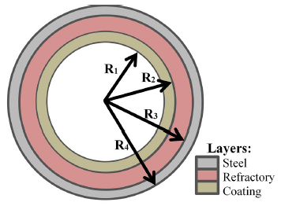

**FIGURE 2.1**

The figure shown above is a schematic of the cross-section of the clinker kiln, showing the layers that make up the wall and their dimensions.

Since the kiln had rotational symmetry with respect to its axis at the centre and was operated in rotation constantly, it was assumed or considered that the temperature in the kiln wall does not change along the angular direction “θ.” Therefore, the derivative of the temperature in relation to θ was neglected. In addition to that, there is no generation or consumption of heat inside the walls of the kiln because there is no chemical reaction occurring inside it. Thus, the heat generation term *q*˙ is neglected in the general heat equation in cylindrical coordinates.

**2.1.1 Construction and discretization of the domain:**

For the construction of the domain, we make use of the finite difference method (sounds similar to the finite element analysis which is a popular theoretical concept among mechanical engineers), a longitudinal section of the clinker kiln was taken as shown in the figure below.

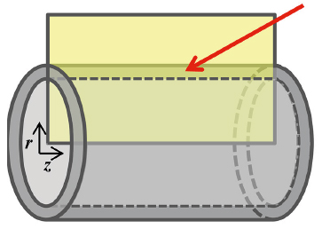

**FIGURE 2.2**

It is important to note that the kiln was oriented or positioned in such a way so that the flame was on the left side, near the origin of the coordinate system. The obtained rectangular domain was 60 m long and 0.6 m high. The figure below shows an illustrative representation of the obtained domain.

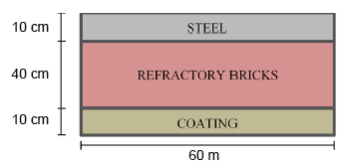

**FIGURE 2.3**

Thermal contact resistance between the layers was neglected since it was small in comparison to the thermal resistance of the three different layers. For the domain discretization, the number of nodes in which each dimension was divided was chosen and named as npZ, npRs, npRr, and npRc. With these values, the ‘steps’ of the mesh were calculated, i.e., the distance between two adjacent nodes. The mesh steps were named as Δz, Δrs, Δrr, and Δrc. The mesh steps were calculated using appropriate formulas.

The experimental kiln shell temperature data were compared with the values provided by the algorithm for the wall surface nodes (Refer to the figure given below). It was seen that the modelled temperature seemed to adjust well to the actual temperatures since the readings of temperature are distributed around the curve of the model. The root mean square error (RMSE) between measured and predicted data was 47 ºC. In the figure below, it can be seen that the measured temperature values varied greatly along the length of the kiln, forming a sinuous distribution marked by peaks and valleys. In a published study on estimation of coating formation in a cement kiln, a tortuous distribution was also obtained for the experimental temperatures measured on the kiln shell. The authors proposed that sharp variations in the measured temperature could be attributed to irregularities in the thickness of the coating layer. Kiln regions where a thicker coating layer has formed exhibit lower temperatures on the outer surface of the kiln due to the insulating property of the coating. Thus, since the model of the present study considered the thickness of the coating layer constant, it was expected that the present model could not predict the experimental temperature profile sinuosities.

Another published study on clinker furnace modelling also came to similar conclusions (Reference 20). Comparing the temperature profile predicted by the model with the values measured along the outer surface of the kiln, the authors from the study of reference 20 noted the presence of several fluctuations of up to ±100 K in the experimental temperatures, as shown in the figure above. These fluctuations were attributed to irregularities of the coating layer and erosion in parts of the refractory. The authors seemed to be satisfied that the predicted temperatures followed the same general trend observed in the experimental values approximately, claiming that the fit was as good as could be expected given the complexity of a real clinker kiln. According to the authors from the paper given in reference 20, an exact comparison between predicted and experimental temperatures is not meaningful, since several characteristics of a real kiln were not considered in the model assumptions, some of the model assumptions is the variation in the thickness of the steel and refractory layers, the variation in emissivity (due to shell coloration), and the variation in heat transfer coefficient (due to spacing of the blowers). Therefore, based on the results shown in the figure above and the conclusions of previous works available in scientific literature, it can be said that the model of this study obtained a satisfactory fit to the temperature values measured on the kiln wall. The first graph in the figure above shows that the model from this study followed the general trend displayed by the experimental values. Oscillational variations in the measured temperatures that were not fitted by the model may have been caused by the coating layer irregularities, as they were not considered in the modelling of the study.

The present study aimed to model the temperature profile inside a clinker kiln wall. The proposed model made use of the heat equation and numerical methods of differential equation resolution to obtain a temperature field inside the wall. The results obtained with the developed model proved to be coherent from the theoretical point of view, i.e., obeyed the principles of heat transfer. Moreover, when compared to industrial temperature measurements, the values predicted by the model were close to the experimental values, with a root-mean-square error (RMSE) of 47 ºC. The quality of the fit obtained by the model was similar to that of other models available in the scientific literature for the shell temperature of a clinker kiln, with deviations that can be explained by irregularities in the coating layer that were not included in the model. One of the main limitations of the model developed in this study is that, since the contents of the kiln were not included in the modelling, the algorithm relies on input for the temperature profile of the internal surface of the kiln, an input that was taken from the literature and may not exactly reflect the real condition of the studied kiln. In addition, simplifications were made for the kiln wall structure, such as the assumption of constant thickness for the wall layers and the consideration of only one type of refractory brick along the entire length of the kiln. A possible application for the model from this study is the comparison of the performances of different refractories by simulating temperature profiles employing different values for the properties of the refractory layer. The model of this study can also be used to infer the refractory wear level by identifying large positive deviations of the experimentally measured temperature from the predicted temperature of the model for the external surface of the clinker kiln. As the next steps for model refinement, it is suggested to consider the different types of refractory bricks along the kiln, with different properties, and to consider the variation of specific heat capacity with temperature.

**2.2 Heat Transfer- Fundamentals and Applications**

**2.2.1 Steady Heat Conduction**

In heat transfer analysis, we are often interested in the rate of heat transfer through a medium under steady conditions and surface temperatures. Such problems can be solved easily without involving any differential equations by the introduction of thermal resistance concepts in an analogous manner to electrical circuit problems. In this case, the thermal resistance corresponds [to electrical resistance, temperature difference corresponds to voltage, and the](http://Civildatas.com/) [heat transfer rate corresponds to electric current.](http://Civildatas.com/) [We start this chapter with one-dimensional steady heat conduction in a plane wall, a cylinder, and a sphere, and develop relations for thermal resistances in these geometries. We also develop thermal resistance relations for convection and radiation conditions at the boundaries. We apply this concept to heat conduction problems in multilayer plane walls, cylinders, and spheres and generalize it to systems that involve heat transfer in two or three dimensions. We also discuss the thermal contact resistance and the overall heat transfer coefficient and develop relations for the critical radius of insulation for a cylinder and a sphere. Finally, we discuss steady heat transfer from finned surfaces and some complex geometrics commonly encountered in practice through the use of conduction shape factors.](http://Civildatas.com/)

**2.2.2 Thermal Resistance Concept**

The equation of heat conduction through a plane wall can be rearranged as

Q= (T1-T2)/Rwall

where, Rwall=L/(kA) which can be denoted as the resistance to heat conduction through a plane wall.

It [is also known as the thermal resistance of the wall against heat conduction or simply known as the conduction resistance of the wall. We should note that the thermal resistance of a medium depends on the geometry and the geometric shape and the thermal properties of the medium.](http://Civildatas.com/)

[The equation for heat flow given above is analogous to the relation for electric current flow, “I”, expressed as](http://Civildatas.com/)

I=(V1-V2)/R

where, “V1-V2” is the potential difference between two points

“R” is the resistance between those two points

“I” is the electric current flowing from one point to the other point.

Thus, the rate of heat transfer through a medium corresponds to the electric current, the thermal resistance corresponds to the electrical resistance, and the temperature difference corresponds to the potential or voltage difference across the medium. We can infer it from the diagrams below,

T1 T2

Rt

where, “T1” and “T2” are the temperatures at two different points shown above and “Rt” is the thermal resistance between those two points shown above.

V1 V2

Re

where, “V1” and “V2” are the potentials at two different points and “Re” is the electrical resistance between those two points.

This is how the analogy between heat and electric current can be visualised.

Now consider a heat convection process happening on a surface with surface temperature “Ts” with surface area “As.”

The heat convection equation can be rewritten as,

Qconv=(Ts-Tfluid)/Rconv

where, Rconv= 1/(h*As) is the thermal resistance of the surface against heat convection, or simply the convection resistance of the surface (Fig. 3–4). Note that when the convection heat transfer coefficient is very large (h tends to infinity), the convection resistance becomes zero and Ts=T. That is, the surface offers no resistance to convection, and thus it does not slow down the heat transfer process. This situation is approached in practice at surfaces where boiling and condensation occur. Also note that the surface does not have to be a plane surface.



*As*

*Ts*

Solid

*h*

*T*

·

*Q*

*Ts*

Q

Rconv

**Figure 2.4 (a)**

When the wall is surrounded by a gas, the radiation effects, which we have ignored so far, can be significant and may need to be considered. The rate of [radiation heat transfer between a surface of emissivity e and area As at temperature- “Ts” and the surrounding surfaces at some average temperature “Tsurr” can be expressed as](http://Civildatas.com/)

Qrad=euAs (Ts-Tsurrounding) =hradAs (Ts-Tsurrounding)

=(Ts­-Tsurrounding)/Rrad

where, Rrad=1/(hradAs) is the thermal resistance of a particular surface with area “As” against radiation or the radiation resistance.

Tsurrounding



*s*

·

*Q*

*R*conv

*Ts*

Solid

*Q*rad

·

Tsurrounding

Rrad

**Figure 2.4 (b)**

Note that both Ts and Tsurr must be in K in the evaluation of hrad. The definition of the radiation heat transfer co- efficient enables us to express radiation conveniently in an analogous manner to convection in terms of a temperature difference. But hrad depends strongly on temperature while hconv usually does not.

A surface exposed to the surrounding air involves convection and radiation simultaneously, and the total heat transfer at the surface is determined by adding (or subtracting, if in the opposite direction) the radiation and convection components. The convection and radiation resistances are parallel to each other, as shown in Fig. 3–5, and may cause some complication in the thermal resistance network. When Tsurr=Ts, the radiation effect can properly be accounted for by replacing h in the convection resistance relation by

hcombined=hconvection+hradiation

When we consider the heat transfer through a plane wall, [Note that the heat transfer area A is constant for a plane wall, and the rate of heat transfer through a wall separating two mediums is equal to the temperature difference divided by the total thermal resistance between the mediums. Also note that the thermal resistances are in series, and the equivalent thermal resistance is determined by simply adding the individual resistances, just like the electrical resistances connected in series. Thus, the electrical analogy still applies. We summarize this as the rate of steady heat transfer between two surfaces is equal to the temperature difference divided by the total thermal resistance between those two surfaces.](http://Civildatas.com/) [Therefore, for a unit area, the overall heat transfer coefficient is equal to the inverse of the total thermal resistance.](http://Civildatas.com/)

[Note that we do not need to know the surface temperatures of the wall in order to evaluate the rate of steady heat transfer through it. All we need to know is the convection heat transfer coefficients and the fluid temperatures on both sides of the wall. The surface temperature of the wall can be determined as described above using the thermal resistance concept, but by taking the surface at which the temperature is to be determined as one of the terminal](http://Civildatas.com/) surfaces. When we know Q, we can find any surface temperature or the temperature of any surface.

**2.2.3 Multilayer Plane Walls**

In practice we often encounter plane walls that consist of several layers of different materials. The thermal resistance concept can still be used to determine the rate of steady heat transfer through such composite walls. As you may have already guessed, this is done by simply noting that the conduction resistance of each wall is L/kA connected in series, and using the electrical analogy. That is, by dividing the temperature difference between two surfaces at known temperatures by the total thermal resistance between them.

Consider a plane wall that consists of two layers (such as a brick wall with a layer of insulation). The rate of steady heat transfer through this two-layer composite wall can be expressed as below,

Q**.** = (T1-T2)/Rtotal

We can infer the case using the diagram below. The total resistance of such a system is represented by the following equation,

Rtotal=Rconv1+Rcond1+Rcond2+Rconv2

Using Q, any temperature at any interface can be determined. The subscripts “1” and “2” refer to the left-hand side surface and the right-hand side surface respectively.

*T* 1

·

*Q*

Wall 1 Wall 2

*T*1

*T*2

*T*3

*T* 2

*R*conv,1

*T* 1

*R*1

*R*2

*R*conv, 2

*T* 2

**Figure 2.5**

The major section for energy consumption is found in industry, transport, agricultural, residential and commercial sector. The most part of the energy consumption in residential and commercial buildings is thanks to the utilization of mechanical devices to take care of a snug indoor environment. Thermal conductivity of building materials is one among the factors that influence the heat transfer in buildings. Thermal conductivity can be reduced by the utilization of materials with low density. The present paper reports the development of a sustainable thermal insulating external wall panel and its mechanical, thermal and durability properties. The wall panel was prepared using foam concrete and rice husk and replacing the cement by fly ash. Strength of panel was tested by conducting in plane bending test and compressive strength test. Thermal conductivity was tested using guarded hot plate apparatus. Durability properties were tested by conducting water absorption test, drying shrinkage and acid resistance test. The test results showed that the rice husk and fly ash content had a significant influence on the thermal conductivity and durability properties of the developed wall panels.

This study has developed a sustainable material for external wall panels which will be able to scale back the thermal conductivity through the walls and supply thermal comfort within the room or in our case or for our purpose of the study, within the reactor to be designed. A rice husk foamed concrete incorporated with high volume fly ash was used to develop wall panels and experiments were performed to judge the feasibility of the product by a determination of its thermal, mechanical and sturdiness properties. the subsequent conclusions were drawn from the study. The thermal conductivity of the panel decreases with a rise in the rice husk content. The thermal conductivity of specimen with 15% rice husk content was 19.05% less than control specimen having zero percent rice husk, and with 60% fly ash replacement, the thermal conductivity was 6.66% less than control specimen having zero per cent fly ash.

**2.3 Estimation of Thermal Conductivity of Rice Husk infused with Concrete**

Thermal behaviour of concrete has relevancy to any use of concrete, particularly in relation to structures wherever it's desirable to possess low thermal conductivity, dimensional stability, high specific heat, and small or no decrease of stiffness upon heating. though a lot of work has been done on the result of admixture and also the mechanical properties of concrete, relatively little work has been done on the thermal conductivity.

**2.3.1 Effect of Moisture on Thermal Conductivity of Concrete**

Thermal conductivity of concrete will increase with increasing moisture content. Since water has a conductivity about 25 times that of air, it is clear that once the air in the pores has been partially displaced by water or moisture, the concrete should have larger conductivity. Steiger and Hurd reported that once unit weight of concrete increased by 1% thanks to the water absorption, the thermal conductivity of those specimens will increase 5%. It was reportable that the thermal conductivity of light-weight concrete changes significantly with porosity. Thermal conductivity of concrete increases with increasing cement content, and thermal conductivity of aggregate. SF causes a decrease within the thermal conductivity and a rise in the specific heat of cement paste. SF additionally causes an increase in the electrical resistivity. However, the result of SF and fa on the thermal conductivity of expanded perlite aggregate concrete (EPAC)has not been previously reported. In view of the worldwide sustainable development, it's imperative that supplementary cementing materials be used in replace of cement within the concrete industry. the foremost world-wide available supplementary cementing materials are silica fume, a by-product of silicon metal, and fly ash, a by-product of thermal power stations. it's estimated that approximately600 million tons of fly ash is accessible worldwide now, but at present, the present worldwide utilization rate of fly ash in concrete is regarding 10%. thanks to the fast economic development and also the growth in the world population consumption of the energy over the world, the fly ash has significantly increased. Thus, air and environment pollution became a problem, then, the concept of using waste material has gained popularity. fa and SF are two of the most common concrete ingredients thanks to their pozzolanic properties. Light-weight concretes, created from lightweight aggregates, have superior properties such as lightness, thermal isolation, freeze–thaw resistance, and fire protection however have disadvantage of low mechanical properties. There are a number of studies concerning the results of silica fume and fly ash on the properties of the normal concretes and concretes made with mixes of ancient and light-weight aggregates. However, there was no enough info about the results of oxide fume and fly ash on the compressive strength, thermal conduction, unit weight etc., of these concretes within the technical literature. Therefore, an experimental investigation concerning effects of silica fume and fly ash on thermal conductivity of EPAC was carried out by us and the results of that are reported.

For the experiment of thermal conductivity for mixture of rice husk and gypsum, guarded hot plate apparatus was used. The use of guarded hot plate was because the apparatus is suitable for experiments on materials that have low values thermal conductivity, ≤2W/m-K. the acceptable temperature range for guarded hot plate method is from -20°C to 100°C. Hence, this method is suitable for the sample which is the mixture of rice husk and gypsum as the sample is estimated having low thermal conductivity. This method of study is following the standard of ASTM C177-85 (U.S.A) and SB 874 and BS 874-Section 2.1 (Britain). The guarded hot plate equipment is easy and doesn't require any calibration process. it is also simple to fabricate and therefore the concept is predicated on heat transfer flow from high temperature surface to low temperature surface. The sample for this method is rice husk and gypsum. The rice husk sample is obtained from Kedah. The preparation of the specimen can begin with the fabrication of the mould. the dimensions of the mould are 209 mm x 209 mm x 50 mm.

The gypsum is set to be constant at 1kg while the weights of rice husk fibre. the aim of the study is to determine whether or not the mixture of rice husk fibre and gypsum can decrease the value of thermal conductivity of pure gypsum as gypsum is known for its thermal insulation properties. The reason we choose rice husk for the mixture with gypsum is to feature value to rice husk because it may be considered as bio-waste product. From the result obtained, the values of thermal conductivity of gypsum and rice husk mixture was found to be decreasing as the quantitative relation of rice husk weightage increase.

**OBJECTIVES**

The objectives of the research work are as follows,

* To devise an algorithm by using the various heat transfer equations by modifying them to fit spherical and cylindrical reactors to find the linear temperature distribution from the inner surface to the outer surface.
* To write a pseudocode and a code in python to execute the monotonous calculations of finding the linear temperature distribution of the spherical reactor from the inner surface to the outer surface of the reactor wall. The temperature distribution is obtained in the form of a list.
* To represent the data obtained by plotting a graph of the linear temperature distribution from the inner surface to the outer surface of the reactor wall either by using matplotlib or panda packages. Bokeh, a simulation module may also be used to represent the linear temperature distribution using colour-coding with RGB features.
* To simulate the temperature profile of a spherical and cylindrical reactor with an insulation of rice husk incorporated foam concrete with various mix designations in python using the bokeh module.

**CHAPTER 3**

**METHODOLOGY**

**3.1 Software Used**

Python is the software used for computational purposes, graphical representation and graphical simulation. Python is not only used for its in-built features but other modules are imported by installing them using the pip command. These modules are used for calculations, graphical plotting and graphical representation and simulation. The names of these modules are “math”, “bokeh” and “matplotlib.”

**3.1.1 Python**

Python is an open-source programming language created by Guido Van Rossum in the late 1980s and its implementation was first started in December 1989 in Netherlands. Thousands of third-party modules for python are hosted in the Python Package Index (PyPI). Owing to its open-source policies, python both has a standard library and a community contributed library. Python is developed under an OSI-approved open-source license, making it freely usable and distributable, even for commercial use. Python’s license is administered by the Python Software Foundation.

**3.1.1.1 Math module**

This module helps us perform mathematical calculations including trigonometric, complex system and hyperbolic functions. The exact value of pi can be used by importing this module for easy calculations. This module provides access to the mathematical functions defined by the C standard.

**3.1.1.2 Bokeh module**

Bokeh is a python module used for creating interactive graphic designs and simulations. It helps us build graphics, ranging from simple plots to complex dashboards with streaming datasets. With Bokeh, we can create JavaScript-powered visualizations without writing any JavaScript ourselves. With a wide array of widgets, plot tools, and UI events in python that can trigger real Python call-backs, the Bokeh server is the bridge that lets us connect these tools to rich, interactive visualizations in the web browsers.

**3.1.1.3 Matplotlib module**

Matplotlib is an amazing visualization module in Python for 2D plots of arrays. Matplotlib is a multi-platform data visualization library built on NumPy arrays and is designed to work with the broader SciPy stack. It was first introduced by the computer scientist John Hunter in the year 2002.

One of the biggest benefits of data visualization is that it allows us visual access to huge amounts of data in easily understandable visuals. Matplotlib consists of several plots like line, bar, histogram, scatter, etc.

**3.2 Brief Description of Procedure**

We are going to attempt to compute the temperature profile of the wall of either a cylindrical or a spherical reactor. For this, we use all the heat transport equations without leaving out anything. We use the heat transfer by conduction, convection and radiation. We know that heat flows either from inside the reactor to the surroundings or from the surroundings to the reactor. To estimate that heat flux, we compute the total resistance offered for this heat flux and it includes the resistance for convection inside the reactor, resistance for conduction at the walls of the reactor, resistance for convection on the outer surface of the reactor, resistance for heat radiation on the outer surface of the reactor.

We assume that steady state heat transfer processes occur in the situation or problem considered for the ease of calculation and computational capabilities in python and also for the ease of algorithm formulation.

During steady state heat transfer, the temperature at a particular point does not vary with time and the heat flux does not vary with time and position.

We also assume that the fluid inside the reactor is uniformly mixed to maintain a uniform temperature throughout the reactor, whether it is spherical or cylindrical.

We consider a reactor of a suitable shape with a particular thickness “t”.

**3.3 Input Parameters Required for Program**

The assumed parameters for the problem are-r1-Inner radius, r2-Outer radius, k-Thermal conductivity, T1infinity-Temperature of inner fluid, T2infinity-Temperature of outer fluid, hi-Inner heat transfer coefficient, ho-Outer heat transfer coefficient.

Using the above parameters, we estimate the temperature profile at the wall of the reactor.

**3.3.1 Accommodation for Radiation and Graphical Representation**

In the procedure, the resistance of radiation is calculated and included in the resistance for convection using the method described in the Heat and Mass Transfer guide by Yunus A. Cengel, Afshin J. Ghajar.

Using the heat flow, the temperature at various interfaces is calculated.

After this, the temperature at every interval of the wall is calculated and stored in a list.

The elements of the list are used to plot a graph with temperature at the Y-axis and distance at X-axis, by using various packages available in python.

**3.4 Procedure**

Consider steady heat conduction through a hot water pipe. Heat is continuously lost to the outdoors through the wall of the pipe, and we intuitively feel that heat transfer through the pipe is in the normal direction to the pipe surface and no significant heat transfer takes place in the pipe in other directions. The wall of the pipe, whose thickness is rather small, separates two fluids at different temperatures, and thus the temperature gradient in the radial direction will be relatively large. Further, if the fluid temperatures in- side and outside the pipe remain constant, then heat transfer through the pipe is steady. Thus, heat transfer through the pipe can be modelled as steady and one-dimensional. The temperature of the pipe in this case will depend on one direction only (the radial r-direction) and can be expressed as T = T(r). The temperature is independent of the azimuthal angle or the axial distance.

This situation is approximated in practice in long cylindrical pipes and spherical [containers.](http://Civildatas.com/)

[Consider a long cylindrical layer (like a circular pipe) of inner radius r1, outer radius r2, length L, and average thermal conductivity k. The two surfaces of the cylindrical layer are maintained at constant temperatures T1 and T2. There is no heat generation in the layer and the thermal conductivity is constant. For one-dimensional heat conduction through the cylindrical layer, we have T(r). Then Fourier’s law of heat conduction for heat transfer through the cylindrical layer can be expressed as](http://Civildatas.com/),

Qcond=-kA(dT/dr)

where A = 2πrL is the heat transfer area at location r. Note that A depends on r, and thus it varies in the direction of heat transfer.

Separating the variables in the above equation and integrating from r = r1, where T(r1) = T1, to r = r2, where T(r2) = T2 and rearranging gives the following equation,

Qcond, cylinder=(T1-T2)/Rcylinder

where,

Rcylinder= ln(router/rinner)/ 2πkL

We can repeat the same analysis as above for a spherical surface as well and we get the results as follows,

Qcond, sphere=T1-T2/Rspherical

where,

Rspherical= (router-rinner)/4πrouterrinnerk

[Now consider steady one-dimensional heat flow through a cylindrical or spherical layer that is exposed to convection on both sides to fluids at temperatures T 1 and T 2 with heat transfer coefficients h1 and h2, respectively, as shown in the figure below. The thermal resistance network in this case consists of one conduction and two convection resistances in series, just like the one for the plane wall, and the rate of heat transfer under steady conditions can be expressed as](http://Civildatas.com/),

Q=(T1-T2)/Rtotal

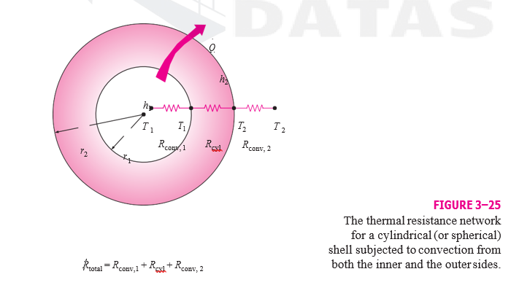

**Figure 3.1**

Note that A in the convection resistance relation Rconv = 1/hA is the surface area at which convection occurs. It is equal to A = 2πrL for a cylindrical surface and

A = 4πr2 for a spherical surface of radius r. Also note that the thermal resistances are in series, and thus the total thermal resis[tance is determined by simply adding the individual resistances, just like the electrical resistances connected in series.](http://Civildatas.com/)

[Steady heat transfer through multi-layered cylindrical or spherical shells can be handled just like multi-layered plane walls discussed earlier by simply adding an additional resistance in series for each additional layer. For example, the steady heat transfer rate through the three-layered composite cylinder of length L shown in Fig. 3–26 with convection on both sides can be expressed as](http://Civildatas.com/)

Q=(T1-T2)/Rtotal

From the figure given below, we can see how multilayered cylinders or spheres can be visualized by splitting it into different resistances in series beautifully including the conductive resistance of the multilayered cylindrical or spherical walls and the inner and outer convective thermal resistance. In the figure given below, there are three different layers with thermal conductivities- “k1”,”k2” and “k3” respectively.

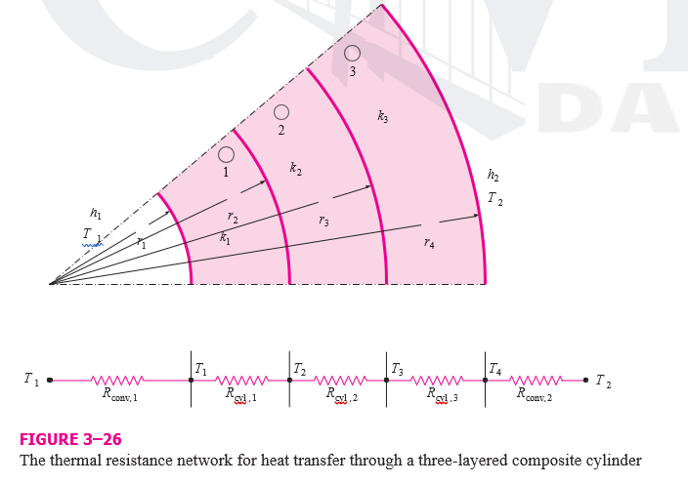

**Figure 3.2**

[The thermal resistance concept can also be used for other geometries, provided that the proper conduction resistances and the proper surface areas in convection resistances are used.](http://Civildatas.com/)

**3.4.1 Algorithm**

The first step for the main project problem is to consider the material of the reactor.

The code would be functional for any material given in the options and new materials with known conductivity can be embedded in it as well.

To get it done, we create a user defined function to assign the value of thermal conductivity based on the material chosen.

Depending on the name of the material inputted by the user, the string is compared with known strings of names of materials and the appropriate value of thermal conductivity is returned to the main function, to the appropriate variable.

Inside the user defined function, if-statements are used to compare the inputted string of the name of the material desired to return the thermal conductivity of that particular material. Unlike the switch-case mostly used in C-programming, in python, we use if and elif to compare the inputted string with different strings to return the desired value of thermal conductivity.

If the inputted string does not match any of the materials embedded in the code, then we use an else statement to print and display to the user that the material inputted is not available in the database and they may enter the value of the thermal conductivity of the material if they know it or choose another material from the given list and print and display the list of materials available.

We ask the user to input the following variables- “r1- Inner radius,” “r2- Outer radius,” “k- Thermal conductivity,” “T1infinity- Temperature of inner fluid,” “T2infinity- Temperature of outer fluid,” “Hi- Inner heat transfer coefficient,” “Ho- Outer heat transfer coefficient.”

The inner and outer radius may be that of a cylinder or a sphere.

To accommodate for these two cases of different shapes of the reactor, we divide the code into two parts that uses different formulas to compute the heat transfer processes based on the shape of the reactor.

To do this, we create a new variable in python called “case” and we ask the user to input what case they want to find the thermal profile of the wall for- spherical or cylindrical.

We declare another variable called “flag” and assign a value to it based on what case the user inputs.

To check what case the user inputs and assign an appropriate value for “flag”, we use if-conditions to compare the inputted string with “spherical” or “cylindrical” and assign the value of “0” if it is spherical and a value of “1” if it is cylindrical.

Based on the value of flag, the rest of the code is executed accordingly.

Since most people tend to mistype the case they want, we take the first letter of the inputted string and assign the value of flag accordingly.

In python, string is one of the most basic data types for a variable and it can be indexed.

So, if someone types “spherival” instead of “spherical”, which can happen often and lead to time waste, we can find the zeroth index of the variable to which the user inputs the case to, in order to get the first letter of the shape of the reactor and assign the value of flag accordingly because most people do not make mistakes while typing the first letter.

The zeroth index of the variable is found using the syntax, variable_name[0], in this case, it would be case[0], in order to get the first letter of the string.

The total number of variables used in this code is 20 and they are- “r1- Inner radius,” “r2- Outer radius,” “k- Thermal conductivity,” “T1infinity- Temperature of inner fluid,” “T2infinity- Temperature of outer fluid,” “T1- Temperature of the inner surface of the reactor,” “T2- Temperature of the outer surface of the reactor,” “hi- Inner heat transfer coefficient,” “ho- Outer heat transfer coefficient,” “Ai- Inner surface area of the reactor,” “Ao- Outer surface area of the reactor,” “Ri- Resistance to heat convection with respect to the inner fluid,” “Ro- Resistance to heat convection with respect to the outer fluid,” “R1- Resistance to heat conduction inside the wall of the reactor,” “T1r- List created to store the values of temperature of the material of the reactor at different distances from the centre,” “Tr- Variable to store the temperature of the wall at different distances from the centre at every loop to append it to a list,” “r- Variable to denote the distance from the centre in a loop for thermal profile of the wall,” “case- Variable used to determine the shape of the reactor,” “flag- Variable used to determine which block of code to use based on the shape of the reactor,” “s- Variable used to compare strings and return appropriate values of thermal conductivity.”

Based on the value of flag, we move on to the next part of the code.

For the case of a spherical reactor, we calculate the area of the inner surface of the reactor by using the formula,

Ai=4*π*r12

where, “r1” is the inner radius of the sphere.

Then, we calculate the resistance offered to heat convection with respect to the inner fluid by using the formula,

Ri=1/(hi*Ai)

where, “hi” is the inner heat transfer coefficient.

Then, we calculate the outer surface area of the spherical reactor by using the formula,

Ao=4*π*r22

where, “r2” is the outer radius of the sphere.

Using this, the resistance offered to heat convection with respect to the outer fluid is calculated using the formula,

Ro=1/(ho*Ao)

where, “ho” is the outer heat transfer coefficient.

Then, we calculate the resistance offered to heat transfer by conduction at the walls of the reactor using the formula,

R1=(r2-r1)/(4*π*r1*r2*k)

where, “k” is the thermal conductivity of the material of the sphere.

Using all the heat transfer resistances computed above, we find the net heat flux flowing from the inner liquid to the outer liquid or vice-versa. (based on the sign of the heat flux obtained)

We find the net heat flux using the formula,

Q=(T1infinity-T2infinity)/(Ri+Ro+R1)

where, “T1infinity” and “T2infinity” are the temperatures of the inner and outer fluid respectively.

We can now find the temperature of the inner surface and the outer surface of the spherical reactor by using the formula,

T1=T1infinity-(Q*Ri)

Using this value, the temperature of the inner surface of the spherical reactor, we can now find the temperature of the outer surface of the spherical reactor using the formula,

T2=T1-(Q*R1)

The temperature of the outer surface of the spherical reactor can be estimated in any other way as well.

Since this is the formula that used the least amount variables, for high speed of computation, it is used in the code.

To compute the thermal profile of the wall of the reactor, we use the variable “r” to allocate the distance of a particular element of the wall from the centre of the reactor.

Using this distance, we calculate the resistance offered by the wall of the reactor to the heat transfer by conduction up to that particular point by using the formula,

R=(r-r1)/(4*π*r*r1*k)

Using this resistance, the temperature at that particular element is calculated by using the formula,

T1r=T1-(Q*R)

We might wonder if we can really take any point on the wall of the reactor and find the resistance offered and calculate the temperature without taking into consideration the factors of outer convection because if we assume the thickness of the wall to be of that value, the heat flowing out is a factor of the resistance to outer heat transfer convection compared to heat conduction outwards which is a factor of resistance offered to the heat transfer by conduction of the wall.

However, this is not the case because to find the temperature of the outer surface of the reactor, the resistance offered for the heat transfer due to convection of the outer fluid is not a factor and neither is the inner fluid when we use the temperature of the inner surface of the reactor as a reference value. In that case, the resistance offered to the heat transfer by conduction alone plays a role.

So, the formula used to obtain the thermal profile at every interval of the wall is valid and can be used.

To use the steps mentioned before to compute the thermal profile of the wall of the reactor, we use a loop with changing values of “r” and compute the temperature at that point and append it to a list called “T1r”.

The initial value of “r” in the loop is r1+0.005 if you want the intervals to have a gap of 0.005 units.

A while loop is used in the code where the condition is “r<r2”, where “r2” is the outer radius of the spherical reactor.

The increment in the value of the looping variable is by 0.005, i.e., the interval gap we desire for the thermal profile.

Inside every loop, the resistance offered to the heat transfer by conduction up to that particular interval is estimated and the temperature at the end of that interval is calculated.

This computed temperature is appended to the list “Tr” by using the Tr.append(T1r).

For the case of a cylindrical reactor, we employ a very similar process but with different formulas because of the change in shape.

We calculate the area of the inner surface of the reactor by using the formula,

Ai=2*π*r1*L

where, “r1” is the inner radius of the sphere.

and “L” is the length of the cylindrical reactor.

Then, we calculate the resistance offered to heat convection with respect to the inner fluid by using the formula,

Ri=1/(hi*Ai)

where, “hi” is the inner heat transfer coefficient.

Then, we calculate the outer surface area of the spherical reactor by using the formula,

Ao=2*π*r2*L

where, “r2” is the outer radius of the sphere.

Using this, the resistance offered to heat convection with respect to the outer fluid is calculated using the formula,

Ro=1/(ho*Ao)

where, “ho” is the outer heat transfer coefficient.

Then, we calculate the resistance offered to heat transfer by conduction at the walls of the reactor using the formula,

R1= log(r2/r1)/ (2* π *L*k)

where, “k” is the thermal conductivity of the material of the cylinder.

Using all the heat transfer resistances computed above, we find the net heat flux flowing from the inner liquid to the outer liquid or vice-versa. (based on the sign of the heat flux obtained)

We find the net heat flux using the formula,

Q=(T1infinity-T2infinity)/(Ri+Ro+R1)

where, “T1infinity” and “T2infinity” are the temperatures of the inner and outer fluid respectively.

We can now find the temperature of the inner surface and the outer surface of the cylindrical reactor by using the formula,

T1=T1infinity-(Q*Ri)

Using this value, the temperature of the inner surface of the cylindrical reactor, we can now find the temperature of the outer surface of the cylindrical reactor using the formula,

T2=T1-(Q*R1)

The temperature of the outer surface of the cylindrical reactor can be estimated in any other way as well.

Since this is the formula that used the least amount variables, for high speed of computation, it is used in the code.

To compute the thermal profile of the wall of the reactor, we use the variable “r” to allocate the distance of a particular element of the wall from the centre of the reactor.

Using this distance, we calculate the resistance offered by the wall of the reactor to the heat transfer by conduction up to that particular point by using the formula,

R=(r-r1)/(4*π*r*r1*k)

Using this resistance, the temperature at that particular element is calculated by using the formula,

T1r=T1-(Q*R)

We compute the thermal profile as done in the case of the spherical reactor. This computed temperature is appended to the list “Tr” by using the Tr.append(T1r).

**3.4.2 Problem used to verify**

A 3-m internal diameter spherical tank made of 2-cm-thick stainless steel (k = 15 W/m · °C) is used to store iced water at T 1 = 0°C. The tank is located in a room whose temperature is T 2 = 22°C. The walls of the room are also at 22°C. The outer surface of the tank is black and heat transfer between the outer surface of the tank and the surroundings is by natural convection and radiation. The convection heat transfer coefficients at the inner and the outer surfaces of the tank are h1 = 80 W/m2 · °C and h2 = 10 W/m2 · °C, respectively.

Determine:

1. The rate of heat transfer to the iced water in the tank and
2. The amount of ice at 0°C that melts during a 24-h period.

SOLUTION:

A spherical container filled with iced water is subjected to convection and radiation heat transfer at its outer surface. The rate of heat transfer and the amount of ice that melts per day are to be determined.

Assumptions: **1** Heat transfer is steady since the specified thermal conditions at the boundaries do not change with time. **2** Heat transfer is one-dimensional since there is thermal symmetry about the midpoint. **3** Thermal conductivity is constant.

Properties: The thermal conductivity of steel is given to be k = 15 W/m · °C. The heat of fusion of water at atmospheric pressure is hif = 333.7 kJ/kg. The outer surface of the tank is black and thus its emissivity is e = 1.

The thermal resistance network for this problem should be done noting that the inner diameter of the tank is *D*1 = 3 m and the outer diameter is *D*2 = 3.04 m, the inner and the outer surface areas of the tank are,

A1 =πD 2 = π (3 m)2 = 28.3 m2

1

A2 = πD 2 = π (3.04 m)2 = 29.0 m2

2

The solution makes use of the concept of parallel resistances and finds the value of Q. From the value of Q, they find the temperature of the outer interface. But, using the algorithm, we can find the temperature of every interface and even on each point on the wall.

The temperature of the outer surface of the wall was found to be close to 4 degrees Celsius in the problem.

We would use this problem and our algorithm to find the temperature distribution and compare the outer surface temperature obtained from the program from the one given as the solution in this problem from the reference book- Heat and Mass Transfer by Yunus A. Cengel, Afshin J. Ghajar.

**3.5 Coding of Algorithm**

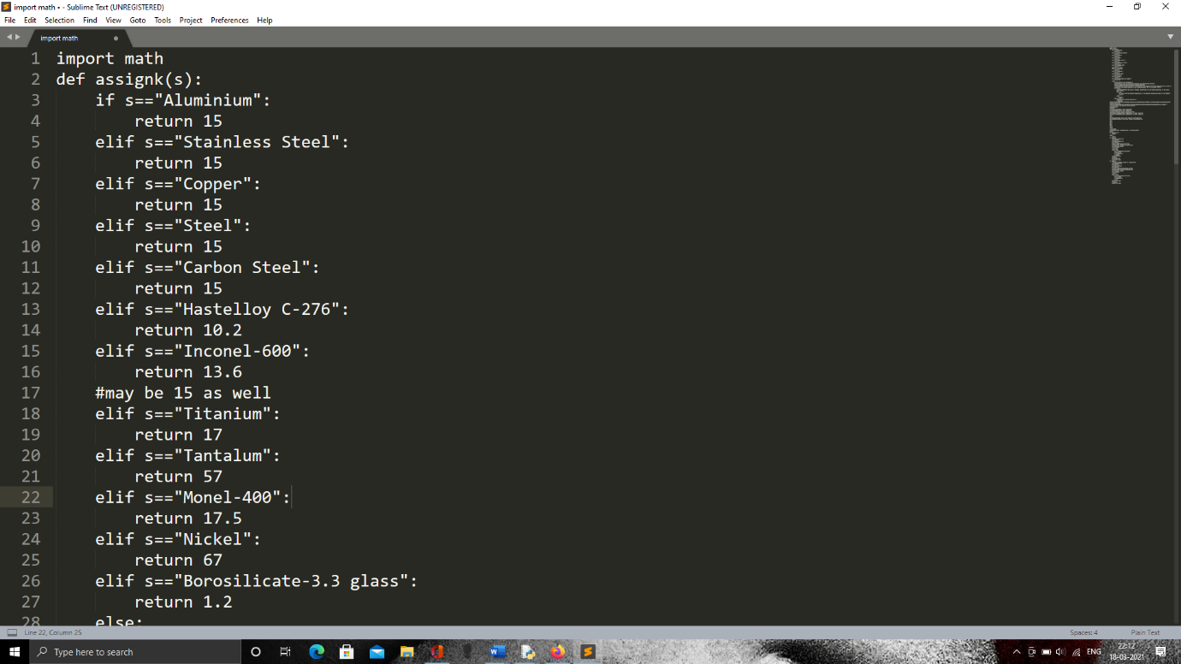

**Figure 3.3 (a)**

We first focus on the part of the code from which we would be able to obtain the temperature profile of the wall during the steady state of either a spherical or a cylindrical reactor.

We may require a lot of mathematical functions to make computations in our code so we import a very useful package called math into the code.

The math module provides access to the mathematical functions defined by the C standard.

It has a wide range of functions available and a list of such functions is readily available online.

The functions are very easy to use and the syntax for using such functions is math.function_name.

To make use of the math module, we need to import it into our code otherwise an error would occur.

Importing the math module is very simple in python and the syntax is “import math.”

Next, we need to create a database of many materials available which are normally used to construct reactors.

We create this database and ask the users to choose from the list available.

To do so, we create a UDF-User Defined Function and we call the user defined function based on the input given by the user.

Based on the input given by the user, the user defined function would return a particular value to the variable with which the function was called, in this case, the variable is k-thermal conductivity.

The name of the function is assignk(s) and the user defined function is called with the name of the material used to construct the reactor inside the brackets/paranthesis in place of “s.”

After function is called, the name of the material which is of the string data type is compared with the database of materials available which is also of the string data type and an appropriate value is returned.

The input string and the string in the databases are compared using the if-condition and “==.” We check if the input string and the string in the database are equal by using “==” as one equal-to sign is used to assign values to variables and two equal-to signs are used to compare and check if two data types are equal or same.

Since we need to compare with an entire database of materials available of the string data type, we need to make use of a string of if-conditions.

If the input string is not the same as the first string in the database, then it should check with the next string and we may have to check with all the remaining strings as well.

Using a normal if-else condition would check only for two cases, so we use if-elif-else statements. In if-elif-else statements, we make use of multiple if statements, i.e., elif statements, to check the input string with every string available.

If any of the conditions are true, i.e., any of the available string matches the input string, we need to return a specific value, which is the thermal conductivity of the name of the material the user had inputted and in order to do this, we use the return statement.

The syntax for return statement is very simple in python- “return value.” When this line of code is executed, the other elif and else condition blocks are not executed and directly goes to the next line after the function call. This saves time and computational energy.

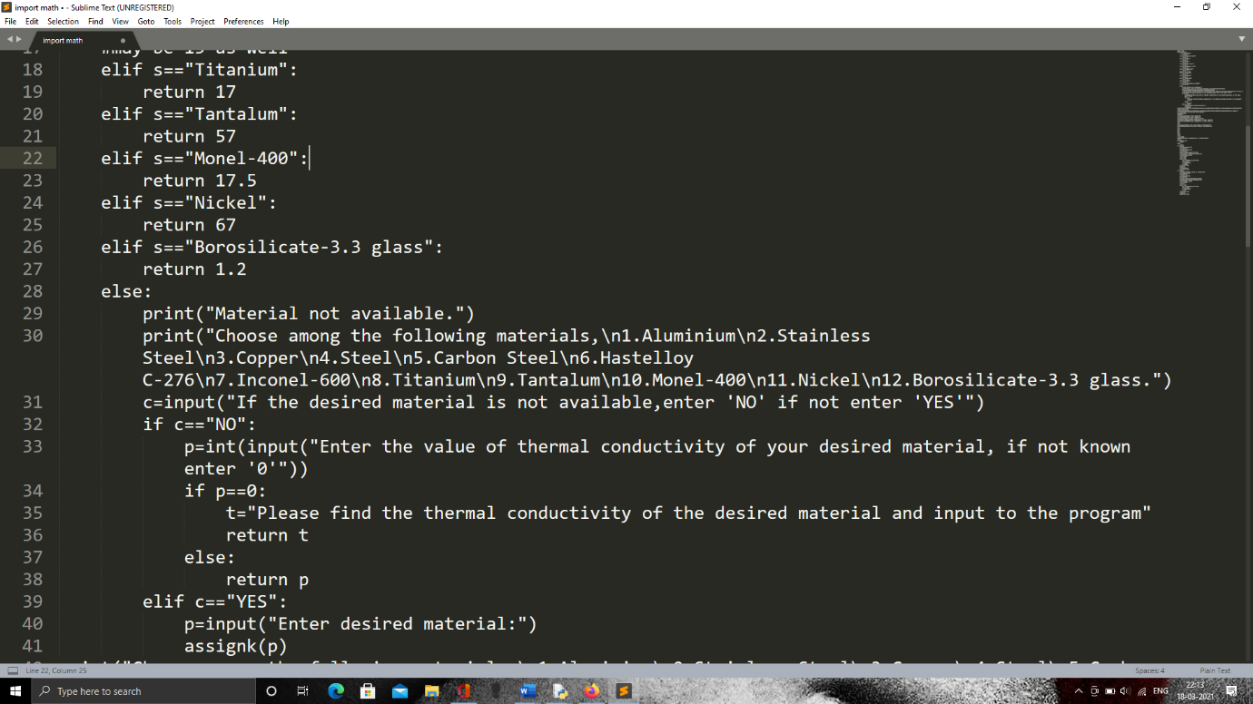

**Figure 3.3 (b)**

Now, we need to consider the case where the input string by the user is not available in the database created. To account for that, we make use of the else-condition block where we print and display to the user that the inputted material is not available. To do so, we make use of the very simple print() function, inside which we make use of quotes to print in the string format-“Material not available.” The syntax for such a function is print(“string_desired_to_be_displayed”).

After this, we again print out the available materials with known thermal conductivities making it easier for the user to choose.

We create another variable called “c” and ask for an input from the user prompting with the string- “If the desired material is not available, enter ‘NO’ if not enter ‘YES’”.

Such a method to ask for an input of the string format along with a message can be done with the following syntax, c=input(“Message”).

Now, the expected input from the user is either “YES” or “NO” and based on that, we would execute the rest of the code.

The user would input “NO” if his desired material is not available and he would input “YES” if his desired material is available.

We make use of if-conditions again to compare the input string with the strings- “YES” and “NO” using the “==” operator.

If the user input was “YES”, we ask the user to input the name of the material which he desires to use to construct his reactor using the variable “p” with the syntax-p=input(“Enter desired material.”). After the user inputs the string, we call the user defined function once again passing this string as the parameter. The user defined function is once again called and an appropriate value is returned. This calling of a function inside the same function is known as recursion. If the user makes a mistake in entering the string, the same thing would happen and if he once again enters “YES” to the input for the variable “c” and makes the same mistake again, it would be a never-ending process because of the recursive nature of the function.

If the user input was “NO”, we ask the user to input the value of the thermal conductivity of the desired material which is not available in the database or the list displayed to the user before this input using the variable “p” with the syntax-p=int(input(“Enter the value of thermal conductivity of your desired material, if not known enter '0'")). We use int() function to convert the input string into an integer. We may use the float() function to convert the input string into a decimal. Even though the user enters numbers for thermal conductivity, in python, it is always in the string data type and it must be converted. It is advised to use float() function because if the user decides to enter a value with decimal points, an error would occur.

We also ask the user to enter “0” if he does not know the value of the thermal conductivity of his desired material.

Next, we compare the input of the user with “0” using the if-condition and the “==” operator in order to check if the input was zero. If this case is true, we create a variable “t” and assign the string- “Please find the thermal conductivity of the desired material and input to the program" to it and return the variable ”t” in the next line. This return statement would stop the further execution of the user defined function.

If the case is false, it means that the user had indeed entered a value for the thermal conductivity of his desired material of construction and inside the else block, we use the statement “return p”, which returns the value of the thermal conductivity the user had entered and stops the further execution of the user defined function.

With this, the user defined function is over and we move on to the main function.

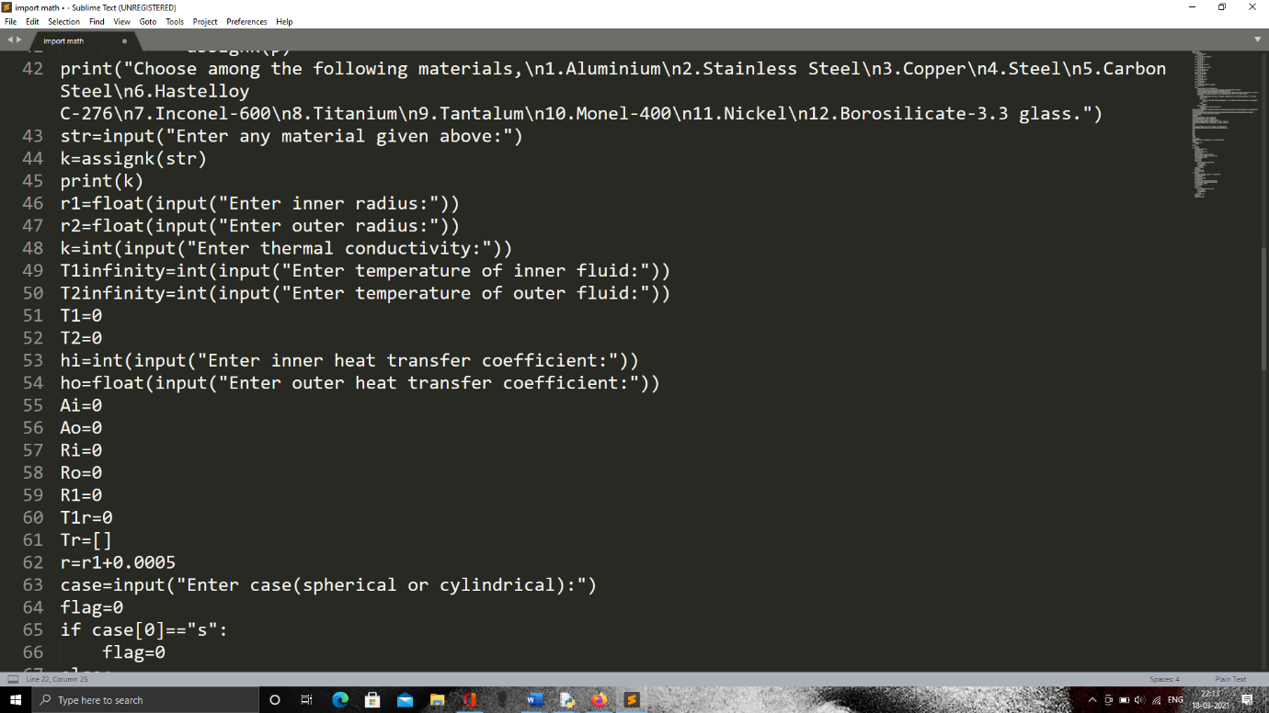

**Figure 3.3 (c)**

In the main function, we display a list of materials using the print() function and ask the users to enter any of the materials displayed.

We display the list of materials using the “\n” in between which makes the cursor skips to a new line, making the code look simple and easy to use.

We use the variable str to ask for the input of the material from the user using the input() function and assign a value to str which is of the string data type.

Next, we call the USD- User Defined Function with the string inputted by the user to str.

The USD-User Defined Function executes a block of the code and returns a value back.

This value assigned to the variable “k” is the thermal conductivity of the material of the reactor.

One of the values that could be returned from the user defined function is a string containing a message for the user, in order to display that string, we make sure that we print the variable “k”, so that in case there is a message that needs to be conveyed to the user, it is printed.

Next, we ask the user to input the inner and outer radius of the reactor, be it cylindrical or spherical.

We use the int() function to ask for the inner and outer radius of the reactor and assign it to the variables “ri” and “ro.”

Subsequently, we ask the user to input the temperature of the inner and outer fluid and assign it to the variables “T1infinity” and “T2infinity”

Next, we declare variables “T1” and “T2” which is the temperature of the inner and outer surfaces by assigning a value of zero to them. We only declare these variables because this is meant to be estimated using the rest of the code.

Next, we ask the user to input the values of the heat transfer coefficient of the inner fluid and the outer fluid to the variables “hi” and “ho” respectively. We make use of the float() function because the values of the heat transfer coefficients tend to be decimals. In the case we are going to give as an example to prove the efficiency of the code, the outer heat transfer coefficient is a decimal in order to account for the radiation aspect as well.

Next, we declare even more variables which are to be estimated or used in the remaining part of the code and they are declared as- “Ai=0,” “Ao=0,” “Ri=0,” “Ro=0,” “R1=0,” “T1r=0.”

These variables denote the inner surface area of the reactor, outer surface area of the reactor, resistance to heat convection to the inner surface with respect to the inner fluid of the reactor, resistance to heat convection to the outer surface with respect to the outer fluid of the reactor, the resistance to heat conduction from the inner surface to the outer surface or the outer surface to the inner surface of the reactor, the temperature at various points of the thickness of the wall of the reactor in order to determine the thermal profile.

Apart from this, we declare variables that are meant to denote a list for which we need to use a different syntax. The syntax for declaring an empty list is “List_variable=[]”, and in this case, the name of the variable meant to denote a list is “Tr”, so the line of code would be “Tr=[].”

Since we want the thermal profile of the wall at different distances from the centre, we make use of another variable “r”, a variable which we would be making use of inside a loop, either a for loop or a while loop. Such a variable is called the looping variable and the initial value of such a variable will be “r+interval_gap.” The interval gap is decided by the user and whatever input the user gives for the interval gap, the same is used for creating the initial value of “r” and for increments of the same variable “r” inside the loop.

Our next input is assigned to a variable which does not play a major role in the technical aspects of the problem such as the heat transfer coefficients or thermal conductivities. It is a variable used to determine what part of the code needs to be executed next. That is, it decides the flow of the entire code which is written in that particular program file.

We use the variable “case” to determine the shape of our reactor to be designed. The input taken for the variable “case” is of the string data type. The user is expected to enter either “cylindrical” or “spherical” and no other shapes because the rest of the code is designed for those two shapes alone. If required, we can have an if-elif-else condition to check if the user gave a proper input and if they have not, we can ask them to give one proper input from the available options by displaying them using the print() function.

Here, we once again compare the input string with the shapes available (in the form of a string) and decide which part of the code to execute. As mentioned in the algorithm, we only take the first letter of the input code because the user is likely to make a spelling mistake or would not have typed properly but is more likely to type the first word properly. For this, we use the zeroth index of the input string.

According to the shape of the reactor to be designed, which would be inputted by the user, we assign a value to the variable flag. And based on the value of flag, the subsequent blocks of code are appropriately run. Here, we assign the value of “1” to flag if the input string for the variable “case” is “cylindrical” and the value of “0” is assigned to the variable “flag” if the input string to the variable “case” is “spherical.”

If flag has the value of zero, we first use an if condition to check that and if it is true, the following is description of the code that would be executed. We would be making use of all the variables which we had declared and the description of all these variables are given in the algorithm section of this report.

For the case of a spherical reactor, we calculate the area of the inner surface of the reactor with “Ai=4*π*r12.”

Then, we calculate the resistance offered to heat convection with respect to the inner fluid with “Ri=1/(hi*Ai).”

Then, we calculate the outer surface area of the spherical reactor with “Ao=4*π*r22.”

Using this, the resistance offered to heat convection with respect to the outer fluid is calculated with the line “Ro=1/(ho*Ao).”

Then, we calculate the resistance offered to heat transfer by conduction at the walls of the reactor with “R1=(r2-r1)/(4*π*r1*r2*k).”

Using all the heat transfer resistances computed above, we find the net heat flux flowing from the inner liquid to the outer liquid or vice-versa. (based on the sign of the heat flux obtained)

We find the net heat flux with the line “Q=(T1infinity-T2infinity)/(Ri+Ro+R1).”

We can now find the temperature of the inner surface and the outer surface of the spherical reactor with “T1=T1infinity-(Q*Ri).”

Using this value, the temperature of the inner surface of the spherical reactor, we can now find the temperature of the outer surface of the spherical reactor with “T2=T1-(Q*R1).”

To compute the thermal profile of the wall of the reactor, we use the variable “r” to allocate the distance of a particular element of the wall from the centre of the reactor.

Using this distance, we calculate the resistance offered by the wall of the reactor to the heat transfer by conduction up to that particular point with “R=(r-r1)/(4*π*r*r1*k).”

Using this resistance, the temperature at that particular element is calculated by with “T1r=T1-(Q*R).”

If flag has the value of one, we use an if condition again to ensure if the same is true and based on that a particular block of code is executed and the following is the description of the code that would be executed. We would be making use of all the variables which we had declared and the description of all these variables are given in the algorithm section of this report.

For the case of a cylindrical reactor, we calculate the area of the inner surface of the reactor with “Ai=2*π*r1*L.”

Then, we calculate the resistance offered to heat convection with respect to the inner fluid with “Ri=1/(hi*Ai).”

Then, we calculate the outer surface area of the spherical reactor with “Ao=2*π*r2*L.”

Using this, the resistance offered to heat convection with respect to the outer fluid is calculated with the line “Ro=1/(ho*Ao).”

Then, we calculate the resistance offered to heat transfer by conduction at the walls of the reactor with “R1=ln(r2/r1)/(2*π*L*k).”

Using all the heat transfer resistances computed above, we find the net heat flux flowing from the inner liquid to the outer liquid or vice-versa. (based on the sign of the heat flux obtained)

We find the net heat flux with the line “Q=(T1infinity-T2infinity)/(Ri+Ro+R1).”

We can now find the temperature of the inner surface and the outer surface of the spherical reactor with “T1=T1infinity-(Q*Ri).”

Using this value, the temperature of the inner surface of the spherical reactor, we can now find the temperature of the outer surface of the spherical reactor with “T2=T1-(Q*R1).”

To compute the thermal profile of the wall of the reactor, we use the variable “r” to allocate the distance of a particular element of the wall from the centre of the reactor.

Using this distance, we calculate the resistance offered by the wall of the reactor to the heat transfer by conduction up to that particular point with “R=ln(r/r1)/(2*π*L*k).”

Using this resistance, the temperature at that particular element is calculated by with “T1r=T1-(Q*R).”

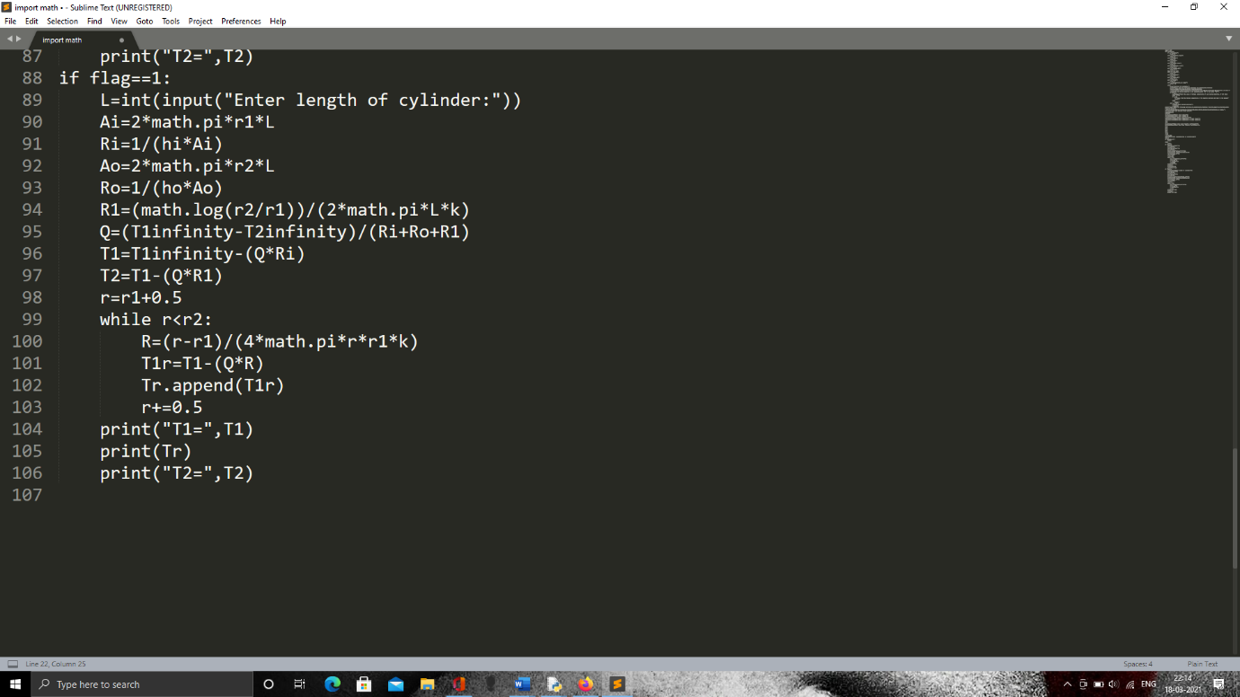

**Figure 3.3 (d)**

For both the spherical and cylindrical cases, the computing of the thermal profile is quite similar or rather very similar.

For a good-looking output, we first display the inner surface temperature by printing “T1” by using the line- print(“T1=”,T1). The text inside the quotes would just display that string and the variable mentioned after comma would print the value of that or rather assigned to that variable.

Then, we print the list which contains the computed thermal profile at every interval by printing the variable “Tr” which is the variable used to denote that list.

Then, we print the outer surface temperature by printing “T2” by using the line -print(“T2=”,T2). This would display T2, that is, the outer surface temperature of the reactor and since this line is after print(Tr), the value of the outer surface temperature will be printed after the thermal profile is printed and hence it would be a good continuous arrangement of the values of temperatures.

**3.5.1 Code for Graphical Representation**

For the code to represent the graphical representation, a unique package called “bokeh” is used. We import the bokeh package using the syntax- “import bokeh.” Then we find out that it gives an error because the file name and the module name is the same. In order to install the bokeh package, we open the command prompt and enter the command “pip install bokeh.” The package downloaded is stored under the same name- “bokeh,” which leads to an error. In order to avoid this error, we use the following syntax to import the necessary files from the bokeh module we would have to use to graphically represent the thermal distribution of the spherical reactor,

“from bokeh.plotting import figure, output_file, show.”

The commands we would be using in our program can be seen from the above line of code that is used to import them, they are- “output_file, figure, show.”

The next figure shown is the cropped screenshot of the code used to represent the thermal profile of the spherical reactor by using its cross-section.

The first line of code is

“output_file("circle.html",title="circles")” which creates the prompt for the output file. This line is used to show that a circle is going to be created with the title- “circles.” The next line of code involves taking the elements of the list that contains the temperatures that constitute the thermal profile which is copied and pasted from the output of the previous code. The next line of code involves the reversing of the list which is copied and pasted and the name of that list is “vr” while the name of the previous list in this code is “v.” The list is reversed by using the splitting operator, also known as the list splitting operator because it is used on lists and is used to slice lists. It is also called the slicing operator. The line of code that uses this slicing operator to reverse the list “v” and stored in “vr” is done using this line of code- “vr=v[::-1].” The next line of code prints the two lists-without reversing and with reversing. It is done to check whether the lists have been properly reversed or not. It is done by writing the following line of code- “print(v,vr).” In order to display the length of this list, we use the “print(len(vr))” line of code so that we know how many different segments of colour shades are going to be used.

After this, we create the figure using the line- “p= figure(title = 'title',x_axis_label='x',y_axis_label='y',y_range=[-1.6,1.6],x_range=[-1.6,1.6]).” In this line of code, we give the title to be displayed on the top left of the graphical plot, the label to be given for X-Axis, the label to be given for Y-Axis, the range of the plot with respect to the Y-Axis and the range of the plot with respect to the X-Axis.

Then, we use the variable “a” as the interval between the different radial points and its line of code is “a=(1.52-1.5)/10.”

Since we come from outside to inside, the initial value of the variable “r” used to print concentric circles is assigned a value of “1.52” which is the outer radius of the spherical reactor as given in the problem. The value of “I”, which is one of the looping variables used in the code to change the intensity of colours is assigned an initial value of one. The variable “k” which is used to display the value of the legends appropriately by looping through the elements of the list “vr” is assigned an initial value of zero. Next, we create a while loop with the condition of “r>=1.5” because we would be creating concentric circles from outside to inside, that is, bigger radius to smaller radius in order for it to be visible. Inside the loop, we used an if condition where the condition is “r!=1.5” because we have a special case for “r” when its value becomes 1.5.

Inside the first if-condition, we type the code- “p.circle(0,0,radius=r,legend_label=(vr[k]),color=(255,(100+(3*i)),0))”

This line of code is used to draw a circle on the figure created with the variable “p” in the earlier part of this code. The first two values inside that function denotes the centre of the circle, and since two zeros are put there, the circle would be drawn at the origin. After that, separated with a comma is the value taken for radius for which we type “radius=Value_of_radius.” After this, in the same function, we type “legend_label=(vr[k])” which is used to create a legend for every colour used to denote a particular temperature range and the range is given in the form of vr[k] which is a list which contains the range in the form of strings and every range is assigned to every colour as “k” keeps changing in every loop. We increment the variable “k” by a value of one at the end of every loop in order to traverse the range list one at a time. We increment the value of the variable “i” by five to cause a more gradual but detectable change in the shades of the colours used to denote every temperature range. We also print the variable “r” to check whether the radius of every concentric circle is assigned the right colour. We decrement the variable “r” by the value assigned to variable “a” in order to notice the change in colour otherwise it will be very gradual and would not be of much importance with respect to representation.

After this, we use another elif-condition instead of an else for a better accuracy of the code and avoid other unknown types of errors and the condition for it is “r==1.5.” When the condition is true, we print the variable “r” once again just as a practise to ensure that the right value of “r” is sued for a particular colour and then we use the same line of code used in the if-condition just before this but make some changes to it. The line of code after making changes is

“p.circle(0,0,radius=r,legend_label=("0-0°C-3.652091800431899°C"),color='cyan').”

We set a default legend_label for this line and the colour is assigned a string of “cyan” in order to print a light bluish colour meant to indicate a big difference between the temperature of the ice-cold water and the inner surface temperature of the spherical reactor.

After this, for further safety and accuracy of the code in order to avoid unknown errors, since we are no longer using the loop as we would like this to be the last step in assigning the colour, we use the keyword- “break” in order to exit the loop and move on to the next line of code.

The next line of code is used to show the figure on which we have done all these manipulations on by using the line- “show(p).”

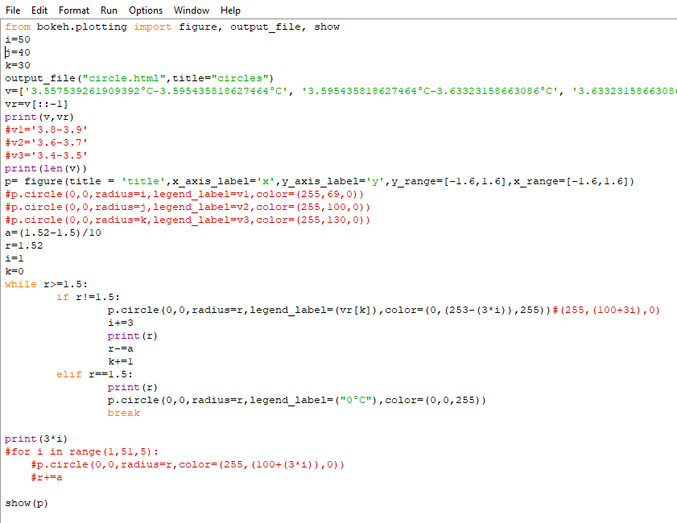

**Figure 3.4**

**3.5.2 APPLICATION**

For the application part, we refer to the study on the variation of thermal conductivity of the rice husk infused concrete which acts as a suitable insulating material. We assume a layer of insulation of a particular radius on the external surface of either the spherical or cylindrical reactor. After assuming such an insulation on the reactor where the insulation also has the same shape as the reactor merely increasing the radius of the overall shape of the reactor, be it spherical or cylindrical in shape.

To stick to the problem we had taken earlier, we would use similar parameters and compare the outer temperature of the spherical or cylindrical reactor with and without the insulation of the rice husk infused concrete. By outer temperature of the spherical or cylindrical reactor in the case of insulation, we mean the outer surface of the overall reactor, i.e., the outer temperature of the external insulation surface and not the interface of the insulation and the reactor.

The input parameters we would be using in the application problem would be very similar with the only difference being that another layer of insulation of 0.1 metre would be added on the spherical reactor.

Apart from that difference, since this is a similar problem but an extra layer with a different thermal conductivity needs quite a few changes in the approach to solve it and create an output for the internal surface temperature, interface surface temperature, external surface temperature and the thermal profile of the reactor material and the insulation material.

We have quite a few new variables that we would be making use of in order to solve this problem in the form of a python program.

The variables are, ri-inner radius, ro-outer radius, r1-radius of first interface, Tiinfinity-temperature of the inner fluid, Toinfinity-temperature of the outer fluid, Ti-temperature of the internal surface of the reactor, T1-temperature of the interface of the reactor and the insulation material, To-temperature of the outer surface of the insulation material, hi-heat transfer coefficient with respect to the inner fluid and the internal surface, ho-heat transfer coefficient with respect to the outer fluid, i.e., the surroundings and the external surface, Ai-internal surface area of the reactor, Ao-external surface area of the insulation material, A1-surface area of the interface between the reactor and the insulation, k1-thermal conductivity of the reactor material, k2- thermal conductivity of the insulation material, Ri- thermal resistance with respect to the inner fluid and the internal surface area, R2-thermal resistance with respect to the interface of the reactor and the insulation and the external surface area of the insulation, R1-thermal resistance with respect to the internal surface area of the reactor and the interface of the reactor and the insulation material, Ro-thermal resistance with respect to the external surface area of the insulation material and the external fluid, i.e., the surroundings, R- looping variable to estimate the thermal resistance at every distance from the centre of the spherical or cylindrical reactor, Tir- looping variable used to take the value of the temperature at every distance from the centre of the spherical or cylindrical reactor, Tr- list variable used to store the temperature at every distance from the centre of either the spherical or cylindrical reactor as its elements, r-lopping variable used to assign the value of the distance from the centre of either a spherical or cylindrical reactor with continuous increments, case-variable used to assign an input from the user to decide whether the following commands should be for a cylindrically shaped reactor or a spherically shaped one, flag-variable used to assign a value in order to manipulate the next line of commands.

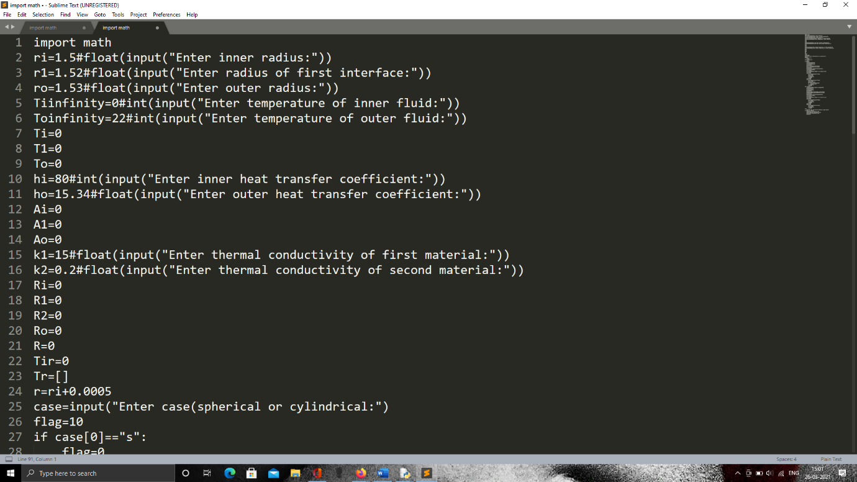

**Figure 3.5 (a)**

Similar to the code given before, we use an if-condition to ask the user for an input for the case he wants to execute the code on, whether it is cylindrical or spherical. Based on that, a value of flag is added by using if-elif condition blocks and the value of flag is decided and assigned inside the particular block based on the user input. We only use the first letter of the user input because it takes less computational capacity to measure one letter and the user is less likely to encounter an error because of the chances of making a typing error, the same was done in the previous code as well.

Now, based on the value of flag, we have three different blocks of code, and in order to execute these three different blocks of code based on the value of flag, we use if-elif-else condition block.

We make use of the double equal to operator, i.e., the “==” operator in order to compare the value of flag with a certain number, and run that particular block of code alone.

First, we will take a look at the case of the spherically shaped reactor with an outer insulation.

We first calculate the respective areas of the spherical reactor, i.e., the internal surface area, surface area of the interface between the spherical reactor material and the insulation material and the external surface area of the insulation material by using the formula- 4*π*r2, where we would substitute the value of “r” accordingly to get the respective areas, i.e., “ri”, “r1”, “ro” would all be substituted to get the respective areas and they are assigned to the variables- “Ai”, “A1” and “Ao” respectively.

Based on the value of the internal surface area of the spherical reactor material, we compute the thermal resistance with respect to the inner fluid and the internal surface area by using the formula- 1/(hi*Ai).

After this, we calculate the thermal resistance to heat conduction caused by the reactor material by using the formula- (r1-ri)/(4*π*r1*ri*k1) with all the parameters with respect to the inner material, i.e., the reactor material.

We use the same thermal resistance formula to calculate the thermal resistance to heat conduction caused by the insulation material by just changing the values of “r1” to “ro” and “ri” to “r1” and “k1” to “k2.”

Since we are importing the math module without giving it a shorter name like “m,” as in “import math as m,” we need to bring in the value of pi by using “math.pi” from the module in the above formulas.

Then we find the thermal resistance to heat convection by the external surface area of the insulation material by using the same formula as the thermal resistance to heat convection at the inner side by just substituting the external surface area of the insulation material and the external heat transfer coefficient as in-1/(ho*Ao).

Similar to the previous problem, we find the net heat transferred using the heat transfer equation that combines the total resistance to the heat flow from the inner fluid to the outer fluid, i.e., the surroundings and the inner fluid temperature along with the outer fluid temperature being involved in the driving force to that total thermal resistance.

We do that with the line of code- “Q=(Tiinfinity-Toinfinity)/(Ri+R1+R2+Ro).” After this, we calculate the inner surface temperature similar to the previously done method by using the inner fluid temperature and the net heat transferred along with the thermal resistance to the heat convection between the inner fluid and the inner surface of the reactor material by using the line- “Ti=Tiinfinity-(Q*Ri).”

Similarly, we can find the temperature of the interface of the reactor material and the interface, which is a little different compared to the one previously done, by using the same formula but since we calculated “R1” which is the resistance up to the distance of the interface, by substituting that, we get the interface temperature. The line of code for that is- “T1=Ti-(Q*R1).”

To find the temperature of the external surface area of the insulation material, we use the thermal resistance “R2” which was calculated using “r1” and “ro,” which signifies the spherical conduction resistance to radial heat conduction up to that point of the outer radius of the spherical reactor. This formula also has a change of using the thermal conductivity of the insulation material, which in this case is rice husk infused concrete with thermal conductivities ranging from 0.2-0.1 W/m-K. (Referred from NR Aravind, Dhanya Sathyanand K M Mini, “Rice husk incorporated foam concrete wall panels as a thermal insulating material in buildings”, Sage Journals, Volume 29, Issue 5)

Next, we compute the net heat transferred similar to the formula used previously just that there are two types of thermal resistances to the spherical radial heat conduction because of the presence of two materials- the reactor and the insulation material. So, we need to add these two resistances which was computed along with the internal and external thermal resistances to heat convection with the difference of the inner fluid and the outer fluid as the driving force part, i.e., the numerator part of the formula to find the net heat transfer from the inner fluid to the outer fluid. The formula for that is- “Q=(Tiinfinity-Toinfinity)/(Ri+R1+R2+Ro).”

The formula to find the internal surface temperature of the reactor material is the same as the one previously done and uses the exact same formula as well. So, in the next line of code, we find the internal surface temperature after which we find the interface temperature of the reactor and insulation material for which the formula is slightly different. It is the same as the previous one with the exception of the change in the variable of thermal resistance used. The thermal resistance used to find the temperature of the interface temperature is “R1” which is the resistance up to the point of the interface that includes only the reactor material as calculated above previously. After that, we find the temperature of the external surface of the insulation material by once again just making a change of the thermal resistance by using the new thermal resistance “R2” which was calculated in the previous lines of the code where it covers the insulation part alone without including the reactor material part.

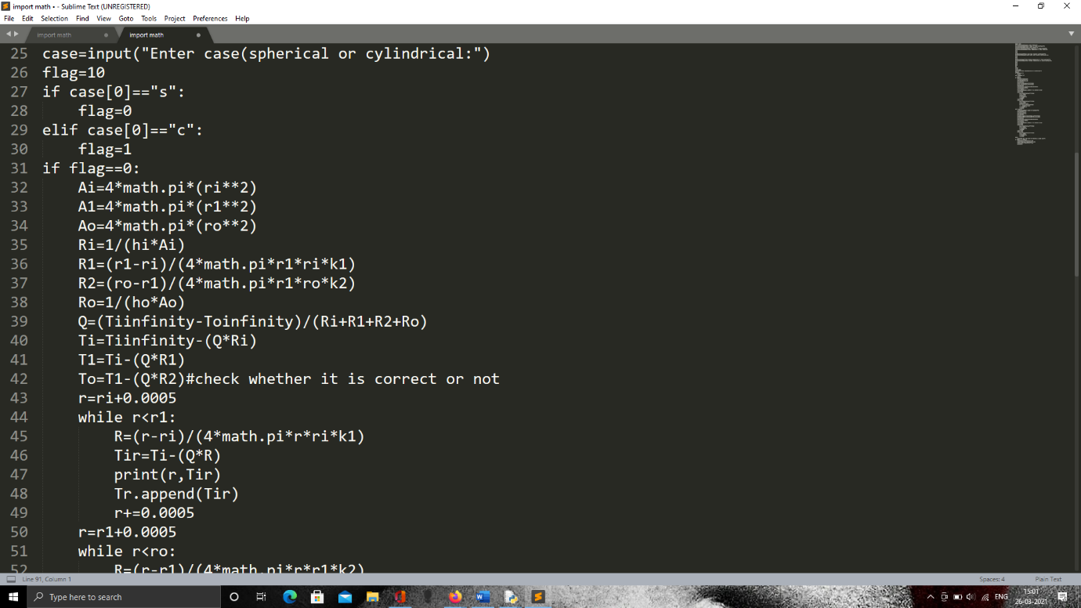

**Figure 3.5 (b)**

Next, we create a looping variable- “r” where we give it a value of the internal radius of the spherical reactor with an increment of the value of interval we desire. We create a while loop with the condition of “R<r1” because we would be finding two sets of thermal profiles, one for the spherical reactor material and another for the insulation material and then we merge the two in order to create the complete thermal profile of the spherical reactor along with its insulation.

Inside the first while loop with the condition mentioned above, we use another variable “R” which is the looping variable of the value of thermal resistance at every interval with the variation of the looping variable- “r” which we use to find the temperature at every interval.

We use the print() function inside the loop to check whether the code is working properly. We use the line- “print(r,Tir)” to do so. Tir is the temperature at every interval calculated and the same is stored in a list before its value is updated in the subsequent loop.

After the computations in the previous loop that involves the thermal profile of the spherical reactor material is done, we move on to another loop which is used to find the thermal profile of the outer insulation material for which we assign the value of “r1+interval size” to it and run a while loop with the condition- “r<ro.”

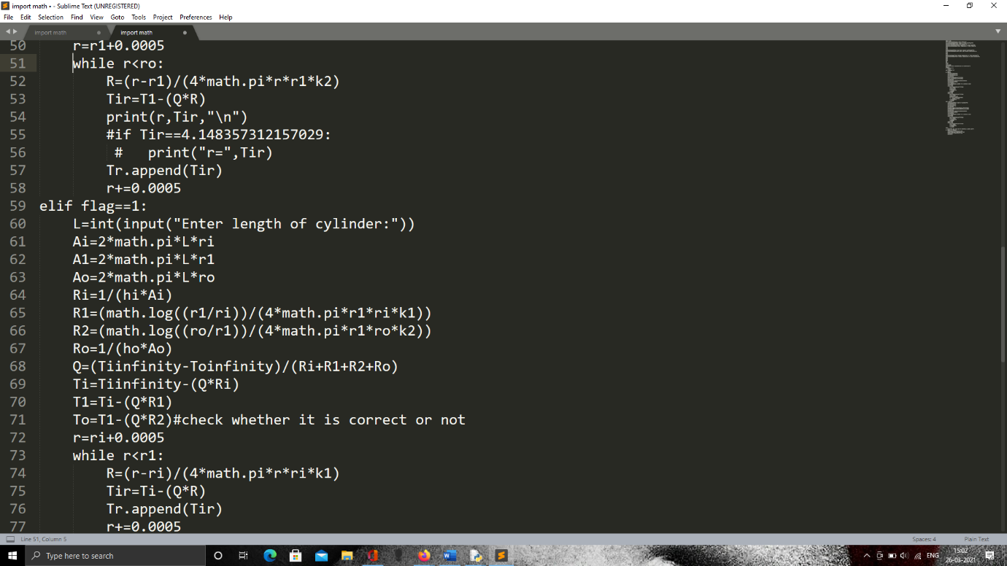

**Figure 3.5 (c)**

Inside this second while loop, we make use of the same “R” value which denotes the thermal resistance with the same formula as in the previous while loop with the changes of thermal conductivity variable to “k2” whereas in the first while loop, we use the variable “k1” for thermal conductivity. We do this because we are finding the thermal profile of the outer insulation material in the second while loop whereas we find the thermal profile of the spherical reactor material in first while loop. We repeat the same lines of code as the previous while loop in the second while loop as well and we append the values of the temperature at every interval into the same list in which we appended the thermal profile of the reactor material.

In both the while loops, we increment the value of “r” based on the size of the interval of the thermal profile.

Now, we move on to the next part of the code where we estimate the thermal profile of the cylindrical reactor with cylindrical insulation when the value of flag is 1.

When the value of flag is 1 and the case is that of a cylindrical shaped reactor with insulation, we need another parameter- “Length of the reactor.”

Apart from this, we make changes in the formulas of finding the internal surface area of the cylindrical reactor material, surface area of the interface of the cylindrical reactor material and the insulation material and the external surface area of the insulation material on the cylindrical reactor.

We use the same formulas that was previously used for the cylindrical reactor’s case over here as well.

The only changes that need to be made is to calculate the thermal resistance of the cylindrical reactor material and the insulation material separately by using the appropriate thermal conductivities in its respective formulas.

One more important change that needs to be made is that to find the thermal resistance “R1,” we make use of the radii- “ri” and “r1” where we consider the radius “r1” as the external radius for the formula of the thermal resistance to radial cylindrical heat conduction and the radius “ri” as the internal radius for the same formula, i.e., the numerator inside the logarithm would be “r1” and the denominator inside the logarithm would be “ri.”

The same case applies for the thermal resistance to radial cylindrical heat conduction of the insulation material denoted by “R2,” where we use “ro” as the external radius and “r1” as the internal radius.

We use the thermal conductivities “k1” and “k2” for the respective formulas as we are dealing with two different materials in each case.

We find the thermal resistance to heat convection of the internal and external surface from or to the inner fluid and the outer fluid by using the same formula with just the area as the value which we calculate in this particular block of code.

Similar to how the coding was done for the spherical insulation material, we follow the same steps.

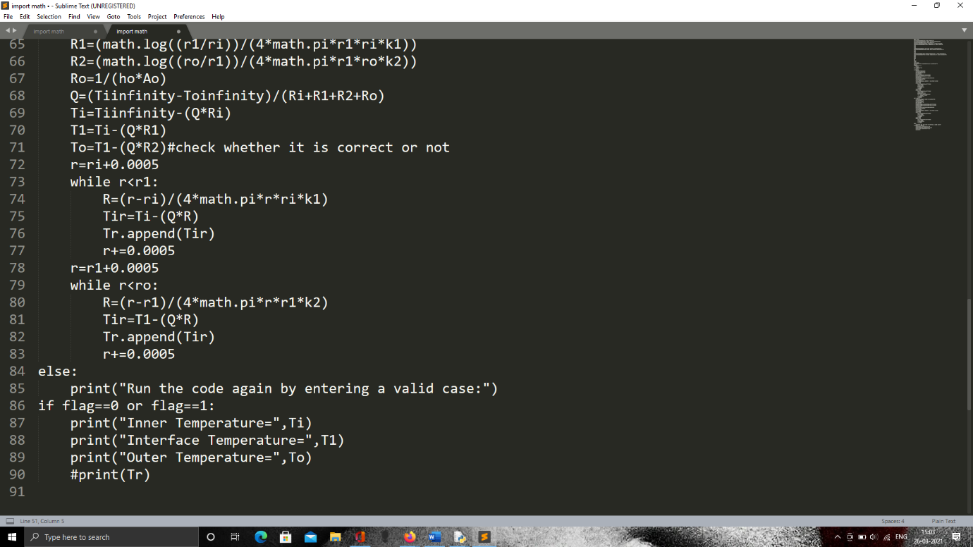

**Figure 3.5 (d)**

In case the user enters an invalid case, we have used an if-elif-else condition in this code where the if-elif part is used to run the blocks of code for the spherical and the cylindrical case respectively and the else condition is used to display a message to the users asking them to enter a valid case by printing the same.

Now, we use another if-condition to check whether the value of the variable “flag” is zero or one and if the condition is true, we print the internal surface temperature, interface temperature, outer temperature and the thermal profile by using the “==” or the double-equal-to operator.

**3.5.2.1 Code for Graphical Representation**

Since the aim for now is to show the graphical representation instead of a simulation, we are going to force changes into the RGB-HEX in order to show a considerable shift in colour changes without shifting so much but just to give a shade. In order to do this, we make use of two different loops. Since the actual problem had blue and light blue colours to signify temperatures ranging from 0 to approximately 2.3 degrees Celsius, we would be taking a slightly yellowish colour to represent temperatures ranging above 3 degrees Celsius.

Since one of the temperature ranges in between is from approximately 2.3 to approximately 5 degrees Celsius, we use a yellower colour to represent an average temperature in that region instead of sticking to a lighter shade of blue.

The code for the graphical representation of a spherical or even a cylindrical reactor with an insulation is shown below,

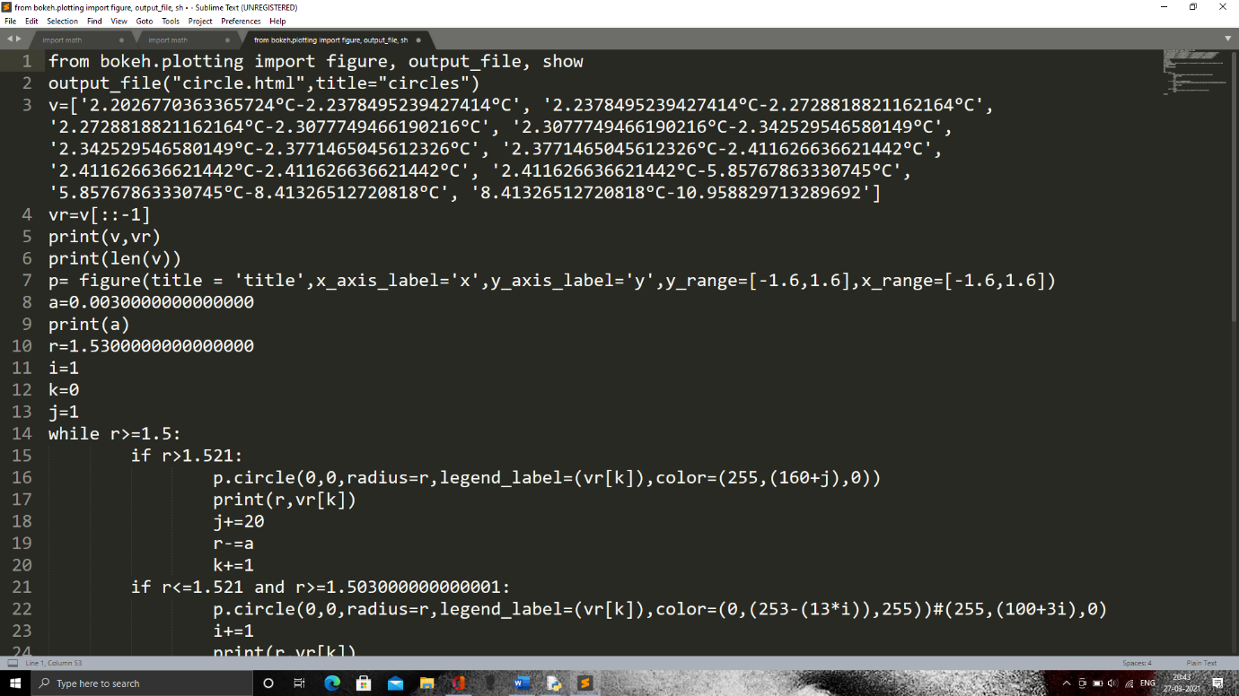

**Figure 3.6 (a)**

The code is similar to the one we use to graphically represent the temperatures at different points of the reactor wall. We just have to do some manual tweaking where we calculate a value and assign it to a variable “a.” The value assigned to variable “a” is given by the formula- a= (outer radius-inner radius)/10. We do this to divide the thickness of the wall into ten different parts and use a colour to represent the temperature ranges between them. We use this value of “a” to divide the thermal profile obtained from the application code and divide it into ten parts and take the values of temperatures at every range and appropriately signify them in the form of a string in a list and we may name the list any way we want and here we have chosen the variable “v.” We reverse this list because we need to plot concentric circles from the outer radius to the inner radius otherwise only the outer radius would be seen and the inner radii apart from that would be hidden behind the circle with the greatest radius, i.e., the outer radius.

We reverse the list with the same method we used to reverse a list in the graphical representation previously, i.e., by using the slicing operation.

Here we make use of an if-elif-elif condition where we use different conditions to plot different colours at different ranges of radii. We take one thing into consideration, since we have plotted the colour blue to around 2.3 degrees Celsius, and we have that range at a distance not exactly as the interface radius, we make use of the ranges at each of the ten parts and find the range closest to this value in order to make a more accurate representation of the thermal profile.

We use the first if-condition to graphically represent the higher temperature ranges and use different ways of coding the RGB values to denote colours with a more orange shade to indicate a warmer region of the thermal profile.

We use the second elif-condition part to denote the cooler ranges of temperature, which in this case is the inner parts of the wall. We use different RGB coding for this region to represent it with a bluer shade to show the cooler aspect of this thermal profile.

The last if condition is used to graphically represent the inner fluid temperature which occupies the majority of the bokeh plot. We use different RGB-HEX codes for this colour as well and we display it only once and we break the loop by using the python keyword- “break.” This keyword can be used to instantly break a loop and move outside it and execute the next line of code which in this case is “show(p)” where “p” is the variable used to hold the figure for the bokeh plot.

Inside every line of code that is used to draw a concentric circle, (actually circle) we need to use a unique legend label because we need to assign the temperature ranges given in the list “vr” which is the reversed list of “v.” For this, we need another variable called “k” that is initialised to zero before the loop starts and we keep incrementing the value of “k” by one every time a circle is drawn. We use legend_label=vr[k] where vr[k] would be the element of the list “vr” which would contain strings we had earlier assigned. When we do this, we got the proper legend label with the appropriate ranges of temperatures with its appropriate colour.

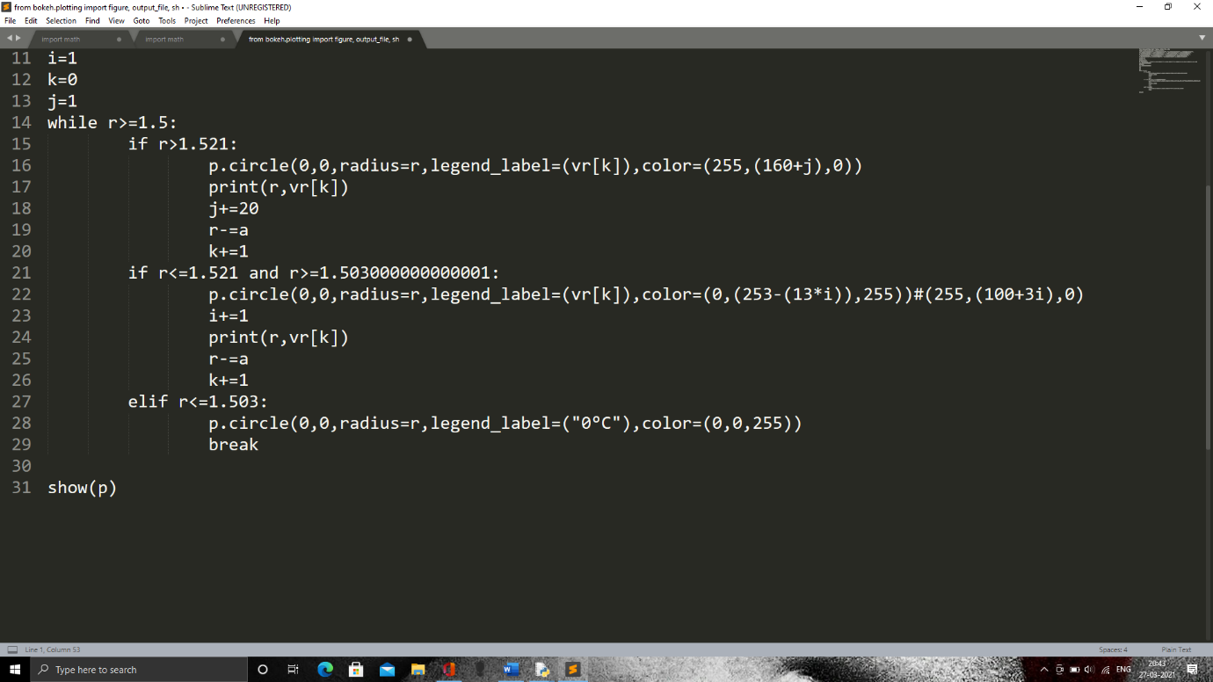

**Figure 3.6 (b)**

We now consider the insulation material of rice husk incorporated foam concrete as our insulation material.

We shall look into the values of thermal conductivities and use them in order to find the internal surface temperature of the spherical reactor, interface temperature of the reactor material and the insulation material, outer surface temperature of the insulation material and the thermal profile of the overall reactor wall.

The table 3.1 below shows the values of thermal conductivities of different mix designations of the insulation material.

|  |  |  |
| --- | --- | --- |
| **Serial Number** | **Mix Designation** | **Thermal Conductivity(W/m-K)** |
| 1 | RH0 | 0.210 |
| 2 | RH5 | 0.198 |
| 3 | RH10 | 0.188 |
| 4 | RH15 | 0.170 |
| 5 | RHF0 | 0.196 |
| 6 | RHF5 | 0.190 |
| 7 | RHF10 | 0.184 |
| 8 | RHF15 | 0.164 |

**Table 3.1**

**CHAPTER 4**

**RESULTS AND DISCUSSION**

**4.1 Input and Output of main problem:**

After the code has been typed fully, we run the code using the “f5” button and the user is prompted to give the inputs so as to get the appropriate output. For the appropriate output, the user is expected to give an appropriate input or only a string would be displayed asking the user to enter an appropriate input.

The inputs which would be given are in the order- “Stainless Steel”,1.5,1.52,0,22,80,15.34, “spherical” for the parameters- Material of reactor construction, inner radius, outer radius, inner fluid temperature, outer fluid temperature, inner heat transfer coefficient, outer heat transfer coefficient, shape of reactor assigned to the variable- “case.”

The screenshot of the input would be as shown in the figure 4.1 (a) below,

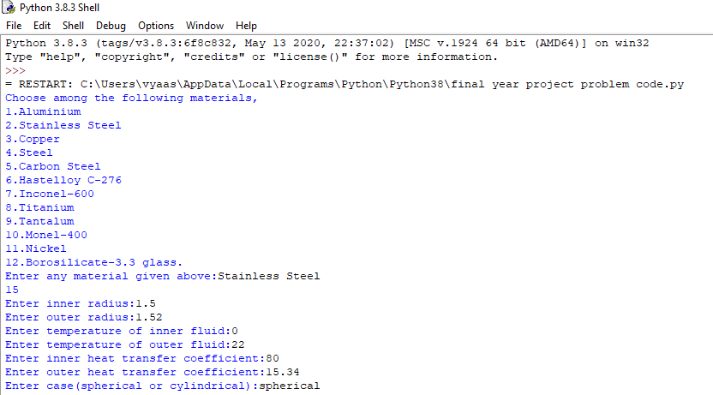

**Figure 4.1 (a)**

From the code we know that the output of the program is in the form of a list. First, we get the inner surface temperature which is a double, then the list with temperatures as it’s elements which is of the double data type, then the outer surface temperature as a double. Since the intervals given in the code is not that small, the temperature profile of the wall thickness would be in the form of a squeezed text. However, the output for this code will be visible since the intervals are not that small and the number of elements is not that large.

The output for the code or program described above is shown in the figure 4.1 (b) below,

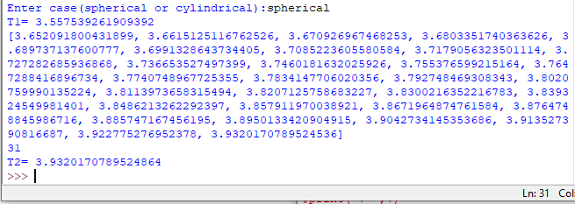

**Figure 4.1 (b)**

**4.1.1Validation of Output Obtained**

The outer surface temperature obtained in the code is really close to the value given as the solution in the reference book. The answer obtained in the code is more accurate because the solution uses a prediction and correction method where it predicted it to be five and then later on confirmed that the value was closer to 4, whereas the output for the outer surface temperature in this code already gives a value of around 3.9320°C which is more closer to the corrected value in the book which is 4°C, compared to the predicted value by the book which was 5°C which the book said can be considered as the right answer because it was close to 4°C. If that is the case, even a value of 3.9320°C is acceptable.

Using the same method given in the problem, the inner surface temperature had also been calculated manually and was checked with the output of the inner surface temperature given by the code and that was also found to be very accurate.

**4.1.2 Graphical Representation**

The output obtained from the code discussed till now only shows the values of the thermal profile in the form of elements in a list, which is indeed a good way of representing the thermal profile but a better way to represent it would be in the form of a graph. Another code has been written to represent the variation of temperature with radius. We just make use of the graphical plot to show the variation in temperature and it should not be used to read values because the origin of the graphical plot is at the centre of the circle and the bottom part of the circle will also have the same value as the top part of the circle even though the graph would show it as negative.

I would make use of the graph to show a particular cross-section of the sphere, which would be in the form of a circle in order to fully encapsulate the variation of temperature out of which we would know the temperature range at every point of the spherical reactor by just extrapolating.

The output obtained from the code written for the graphical representation is as follows,

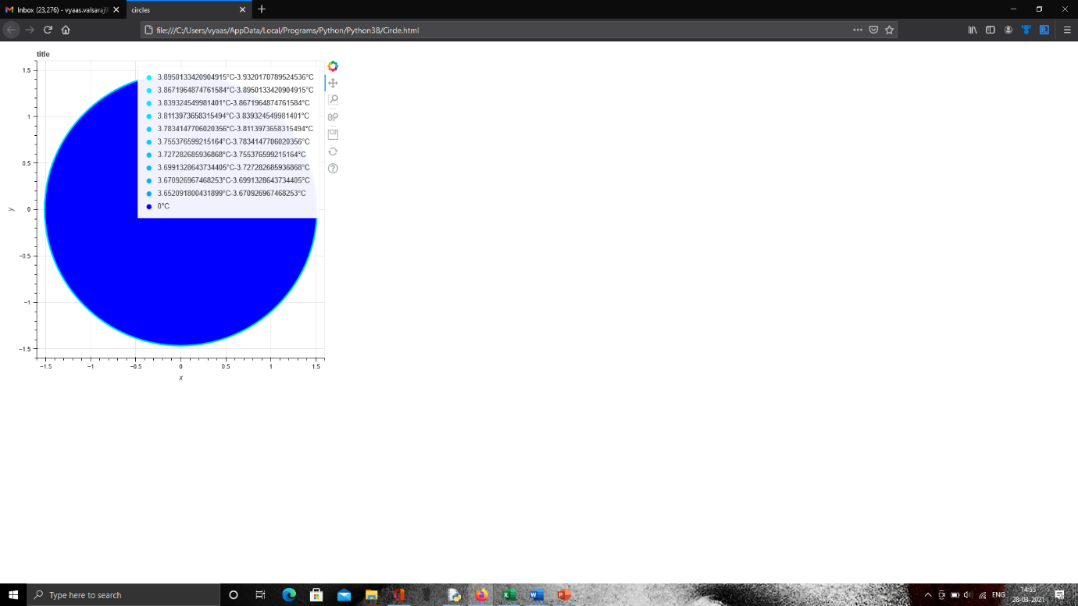

**Figure 4.2 (a)**

The output opens the default browser set in the laptop and use one particular tab to display the circle obtained. This happens because the output uses html which is the short form of “Hyper Text Markup Language” and this language enables the use of a browser to display shapes with colours using graphical plots or even mesh grid.

A close-up look avoiding the other parts of the interface of the browser and the desktop would give a view as follows,

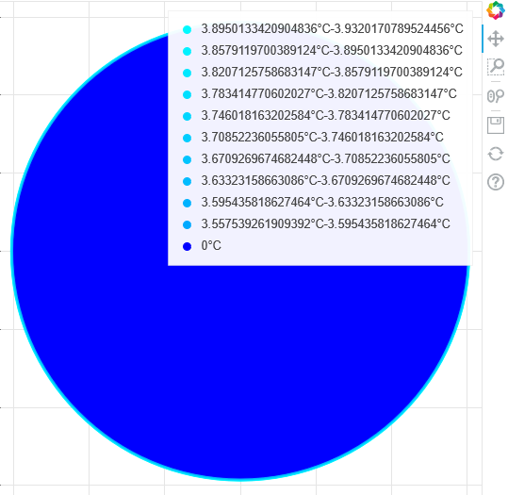

**Figure 4.2 (b)**

From the above figure, we can take a look at the circle which has a cyan colour on the majority of its surface. It is because it represents the temperature range of 0 degrees Celsius to the inner surface temperature. Since the inner volume of the sphere is completely filled with ice-cold water, the temperature throughout is at 0 degrees Celsius because it is assumed that the contents inside the reactor is uniformly mixed. We can see the slight temperature distribution near the walls because the temperature profile is calculated at the wall alone and the thickness of the wall is just 0.2 meters compared to the inner radius of the spherical reactor which is 1.5 meters, and hence the outer radius of the spherical reactor is 1.52 meters.

Since the temperature distribution is done only for those 0.2m and the inner volume temperature of the spherical reactor is also graphically shown, the thermal profile is only viewed slightly.

But we can click on the second and the third button on the graph on the top right (with respect to the number increasing as we go downwards) and toggle the pan and the wheel zoom functionalities. When we toggle these functionalities, we can place the cursor of the mouse on the plot and click the left mouse button to move the figure around in order to adjust it when we zoom in or out. To zoom in or out, we place the cursor of the mouse on the plot and use the scroll wheel of the mouse in order to zoom in or out by scrolling up and down respectively. By using these functionalities, we try to obtain a proper thermal distribution at the wall of the spherical reactor and we have obtained the best possible thermal profile and the screenshot of it is shown in the figure below,

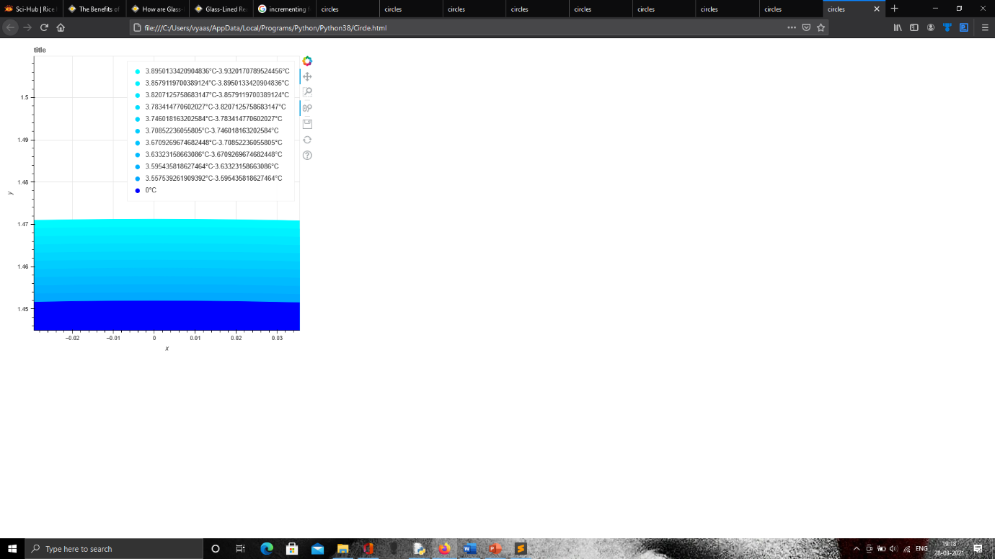

**Figure 4.2 (c)**

To get a clearer view of the thermal profile obtained, we have cropped the screenshot in order to make the thermal profile more visible and the cropped screenshot is shown in the figure in the upcoming pages. From the figure, we can see that the legends for every temperature range have been shown in the top right corner and the range covers temperatures between 0 and 3.9320 degrees Celsius. You can also clearly see the temperature distribution with respect to varying shades of colours. Since the temperature variation overall is not so big, we have just shown it in the form of different shades of orange with the colder temperature ranges being yellow in shades. Only the temperature of the ice-cold water and the immediate inner surface is shown in cyan to represent the big difference in the temperature change of the fluid and the inner surface temperature and the outer surface temperature of the spherical reactor.

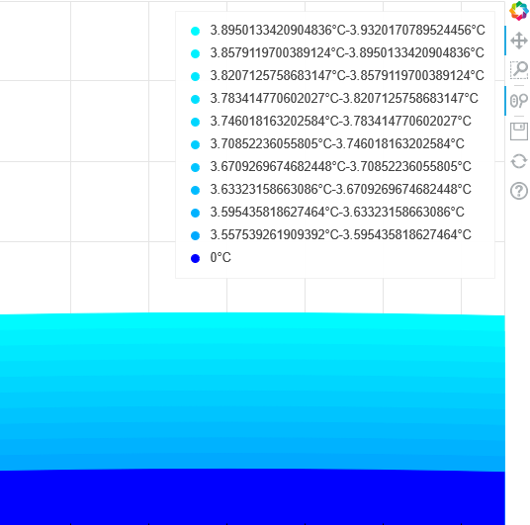

**Figure 4.2 (d)**

**4.2 Input and Output of Application**

For the input, we can make use of the use of user defined functions to get the input from a variety of materials by copy pasting the user defined function from the main code done previously or we can just use the int(input()) function in order to input the value of thermal conductivity yourself.

In this case, since I have taken the value of thermal conductivity of the rice husk incorporated concrete as 0.2, (referred from NR Aravind, Dhanya Sathyanand K M Mini, “Rice husk incorporated foam concrete wall panels as a thermal insulating material in buildings”, Sage Journals, Volume 29, Issue 5) I have chosen the above syntax to input it directly.

So, from the screenshot below, we can see the way in which the user gives the input and based on whatever input the user gives, its appropriate output would come because this is a fully functional code.

For the input, we enter the "inner radius," “radius of first interface," “outer radius," “temperature of inner fluid," “temperature of outer fluid," “inner heat transfer coefficient," “outer heat transfer coefficient," “thermal conductivity of first material," “thermal conductivity of second material,” “case- spherical or cylindrical”

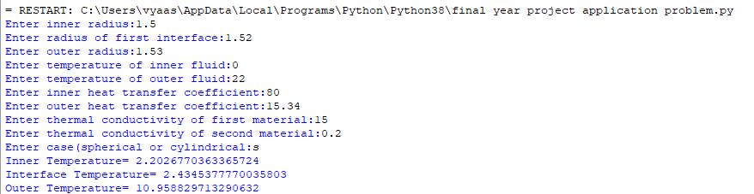

**Figure 4.3 (a)**

We can see the output as well in the figure above where they show the values of the internal surface temperature, interface temperature and the outer temperature.

We notice that the output has a lot of decimals because it is in float format and python tends to make mistakes when dealing with floats, so it is always advised to use the exact float value obtained as the output in cases of doing a design or back tracking with the output as the input and finding if we get the input.

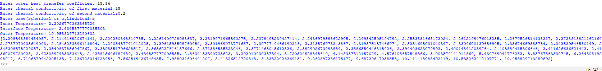

**Figure 4.3 (b)**

In the above figure, we can see the output of the thermal profile as elements in a list. We notice that the temperature keeps increasing with increasing index of the list and there is a jump in the difference of every subsequent element in the list because it is the effect of a layer of insulation.

**4.2.1 Graphical Representation**

When we run the code specially designed for the graphical representation of the spherical reactor with insulation, we get the output as the one given below. Here, we notice that the ice-cold water which is fully filled inside the spherical reactor is shown as dark blue while there is a considerable shift in the blueness from the surface of the inner reactor wall. It is because the temperature of the internal surface of the spherical reactor is quite larger compared to the fluid inside the spherical reactor. We notice another considerable change in the colour at the wall of the reactor because the temperature range at those intervals are quite high and since the colour over here denotes only the range, we have chosen a colour which represents the average of the ranges and hence there is a considerable shift in the colour after a particular point on the reactor wall.

The figure given below is the raw output of the graphical representation of the application problem and hence, we are not able to see the colour coding of the thermal distribution at the wall clearly because the thickness of the wall is quite comparably less with respect to the internal radius of the spherical reactor. But still, we are able to see the colour shifts which is an effect of the insulation on the outer layer of the reactor.

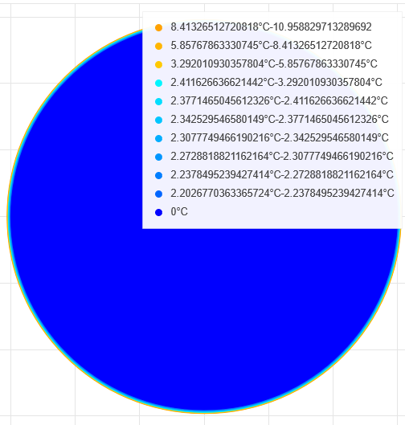

**Figure 4.4 (a)**

We can see the legends on the top right-hand side corner of the bokeh plot where the temperature ranges of every interval are given along with its colour which has been coded to it.

The zoomed-in version of the bokeh plot is shown in the figure given below.

The figure given below shows the wall of the reactor being split into ten different ranges because the gradual changes in colour is very hard to notice in the bokeh plot by the naked eye and since this is just a graphical representation and not a simulation as such, we have decided to just give a representation of how the temperature distribution is going to look like with the help of colours and its shades using the RGB-HEX values which are available in the python package-bokeh (referred from)

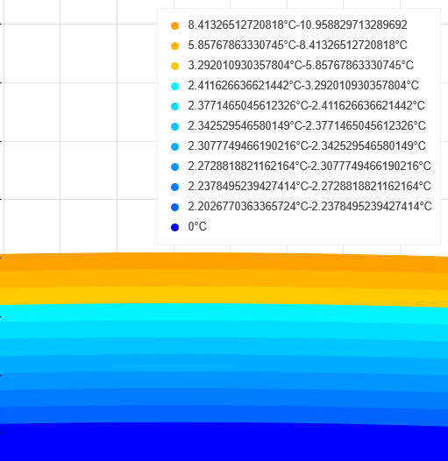

**Figure 4.4 (b)**

**4.3 Input and Output of Mix Designations**

The output of the various mix designations has been screenshotted and are shown below.

The following is the output for RH0 mix designation.

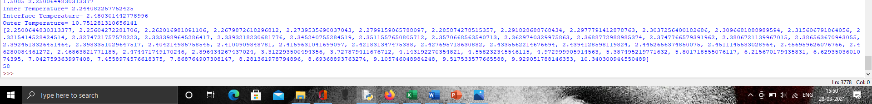

**Figure 4.5 (a)**

The following is the output for RH10 mix designation.

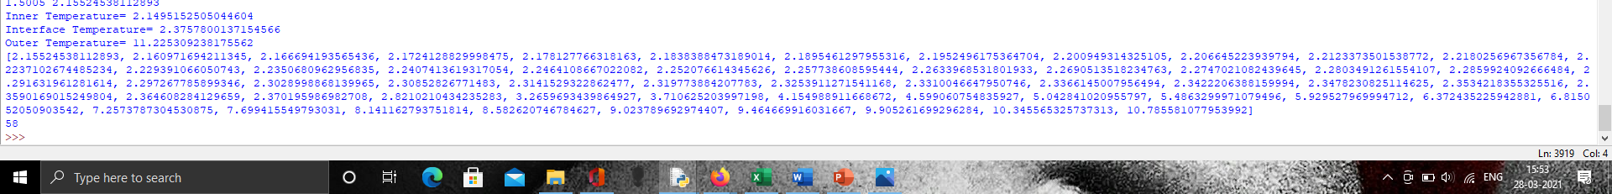

**Figure 4.5 (b)**

The following is the output for RH15 mix designation.

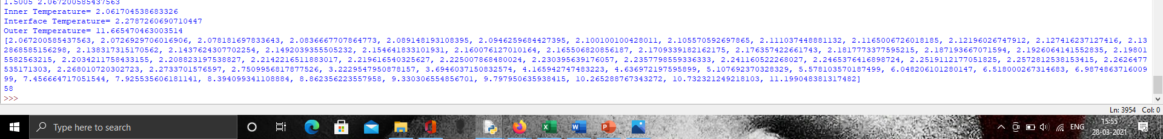

**Figure 4.5 (c)**

The following is the output for RHF0 mix designation.

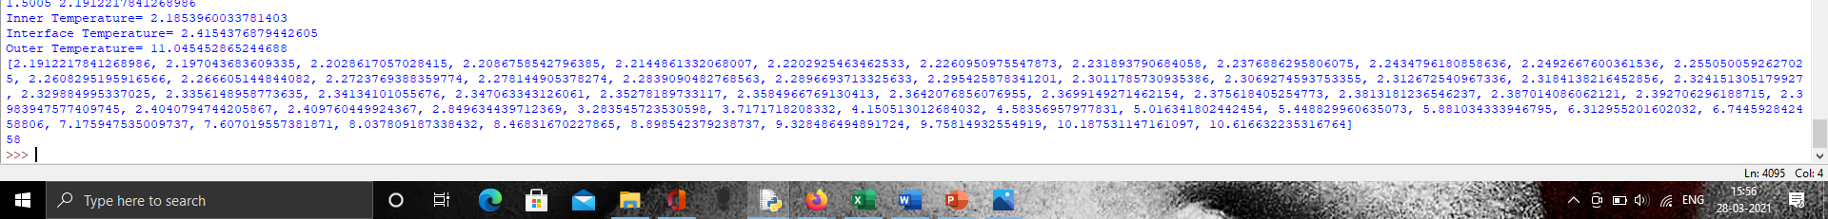

**Figure 4.5 (d)**

The following is the output for RHF5 mix designation.

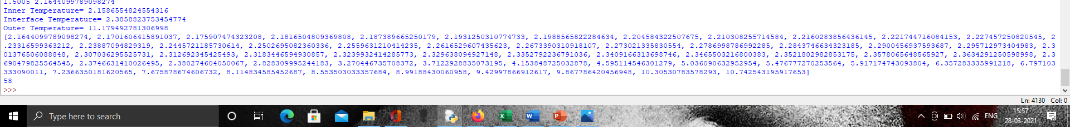

**Figure 4.5 (e)**

The following is the output for RHF10 mix designation.

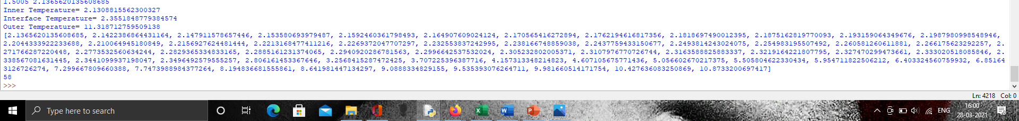

**Figure 4.5 (f)**

The following is the output for RHF15 mix designation.

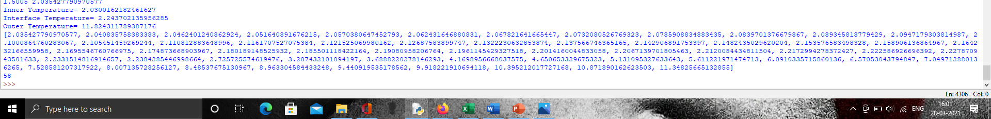

**Figure 4.5 (g)**

We use the code of the application with the thermal conductivity of RH5 because its value is close to the value taken as an example.

When we do that, the output of the program is as follows,

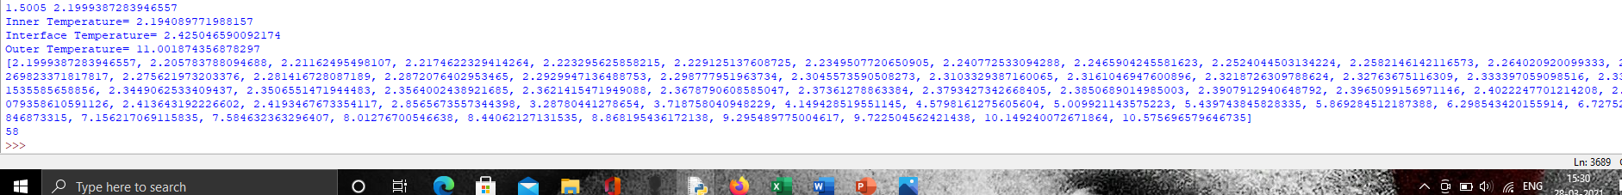

**Figure 4.5 (h)**

The tabulation of the thermal profile has been done and is shown below,

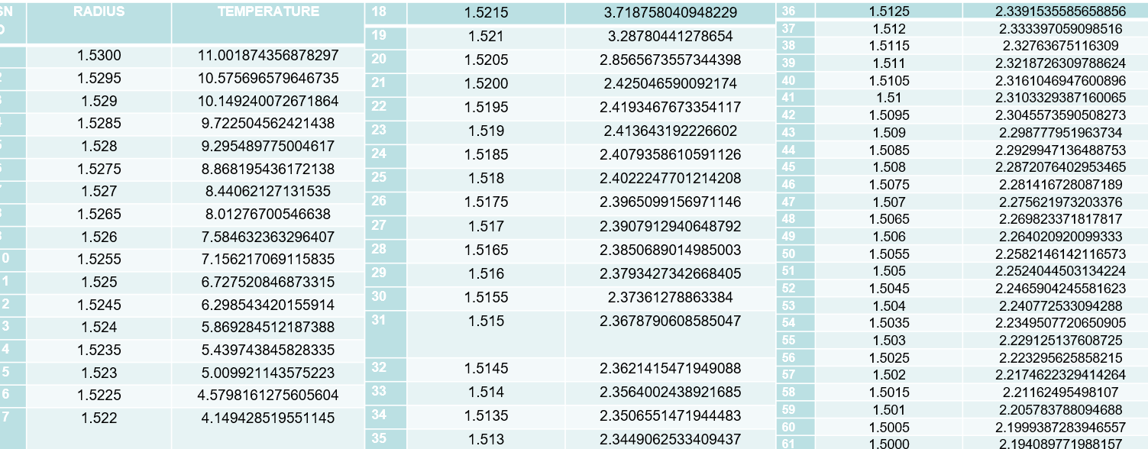

**Table 4.1**

**4.3.1 Graphical Simulation**

Now, we move on to do a simulation of the various compositions of the rice husk incorporated concrete with and without fly ash.

For that, we use the RGB-Hex tuples in a different way compared to the graphical representation.

We would have to assign a particular colour to every temperature needed and the region having that particular temperature should have one colour alone, the colour assigned to it by the tuple.

In order to do this, we create two variables as lists preferably with the names- “t” and “g”.

The variable “t” represents the temperature to which colour would be assigned and the variable “g” represents the G-Value of the RGB tuple.

The interval for the elements in the variable “t” is 0.01 and for the elements in the list “g” is kept as 0.25.

This is because the extremes of the temperatures that are there in our case is from approximately 2 and approximately 12 and in order to avoid getting negative values for the G in the RGB tuple.

The resulting lists are going to be our database for assigning the colours to the temperature regions on the overall wall of the spherical reactor.

The following are the simulations done for the various compositions of the rice husk incorporated concrete with and without fly ash.

The simulation for RH5 is as follows and is shown in the figure 4.6 (a).

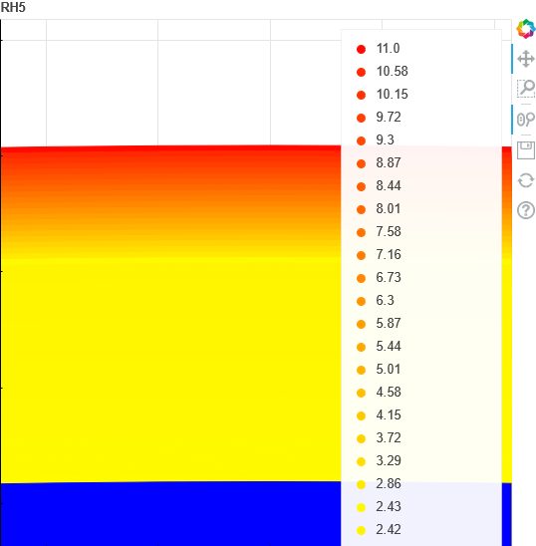

**Figure 4.6 (a)**

The simulation for RH0 is as follows and shown in the figure 4.6 (b).

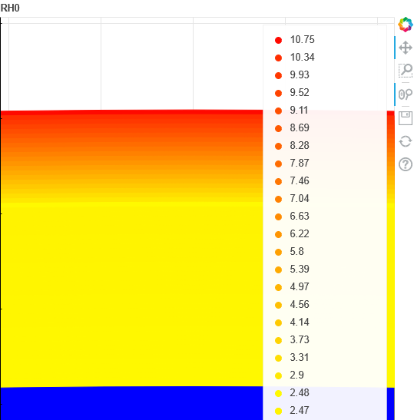

**Figure 4.6 (b)**

The simulation for RH10 is as follows and is shown in the figure 4.6 (c).

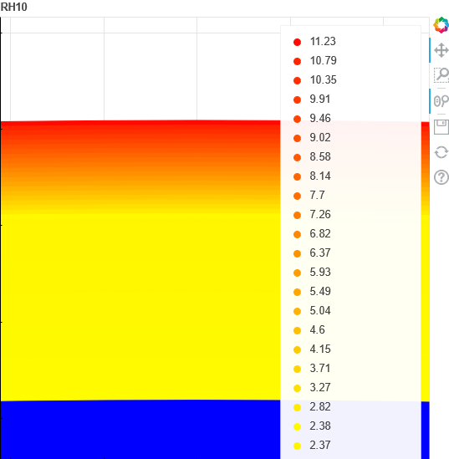

**Figure 4.6 (c)**

The simulation for RH15 is as follows and is shown in the figure 4.6 (d).

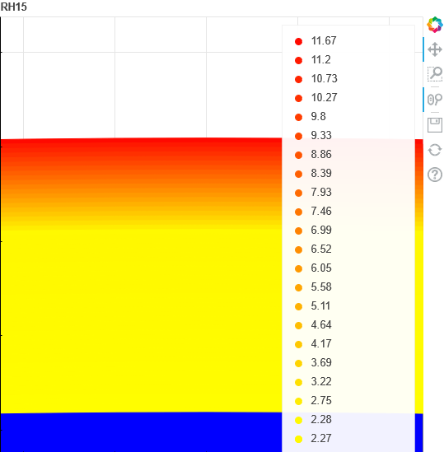

**Figure 4.6 (d)**

The simulation for RHF0 is as follows and is shown in the figure 4.6 (e).

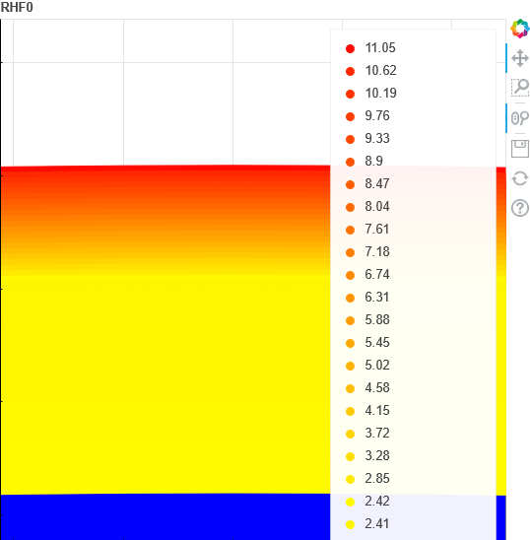

**Figure 4.6 (e)**

The simulation for RHF5 is as follows and is shown in the figure 4.6 (f).

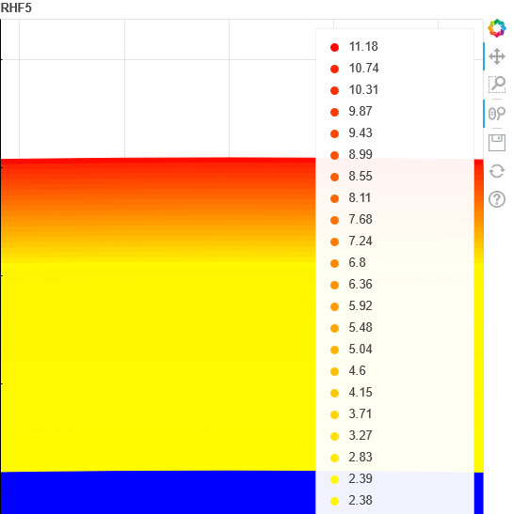

**Figure 4.6 (f)**

The simulation for RHF10 is as follows and is shown in the figure 4.6 (g).

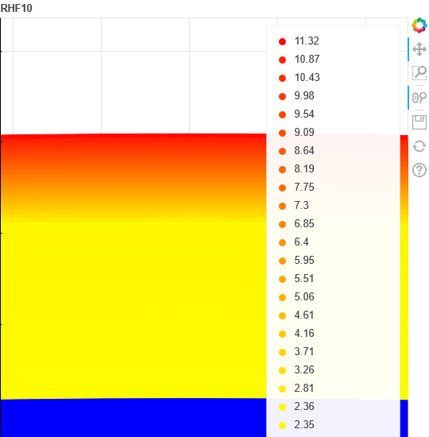

**Figure 4.6 (g)**

The simulation for RHF15 is as follows and is shown in the figure 4.6 (h).

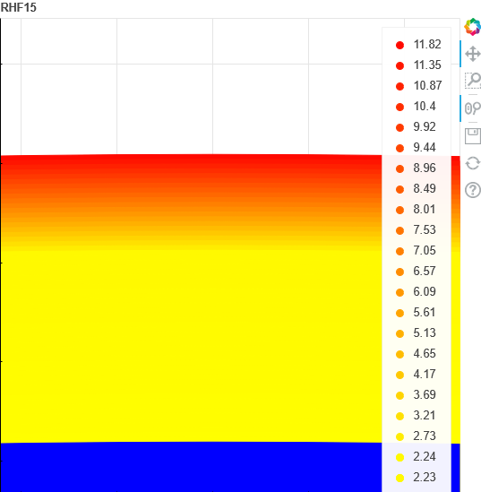

**Figure 4.6 (h)**

The outer surface temperatures of the spherical reactor with insulation were compiled for various mix designations and compositions of the insulation materials and is given in the table 4.2 below.

|  |  |  |
| --- | --- | --- |
| **S. No.** | **Mix Designation** | **Outer Surface Temperature** |
| 1 | RH0 | 10.751281310656141 |
| 2 | RH5 | 11.001874356878297 |
| 3 | RH10 | 11.225309238175562 |
| 4 | RH15 | 11.665470463003514 |
| 5 | RHF0 | 11.045452865244688 |
| 6 | RHF5 | 11.179492781306998 |
| 7 | RHF10 | 11.318712759509138 |
| 8 | RHF15 | 11.824311789387176 |

**Table 4.2**

The percentage change of the outer surface temperature with rice husk incorporated mixture with different concentrations of rice husk is shown in the table 4.3 below.

|  |  |  |
| --- | --- | --- |
| **S. No.** | **Mix Designation** | **Percentage Change** |
| 1 | RH0 | - |
| 2 | RH5 | 2.33082029 |
| 3 | RH10 | 2.03088014 |
| 4 | RH15 | 3.921150104 |

**Table 4.3**

The percentage change of the outer surface temperature with rice husk incorporated mixture with different concentrations of rice husk along with fly ash is given in the table 4.4 below.

|  |  |  |
| --- | --- | --- |
| **S. No.** | **Mix Designation** | **Percentage Change** |
| 1 | RHF0 | - |
| 2 | RHF5 | 1.213530289 |
| 3 | RHF10 | 1.245315695 |
| 4 | RHF15 | 4.466930477 |

**Table 4.4**

The percentage change of the outer surface temperature with rice husk incorporated mixture with and without fly ash is shown in the table 4.5 below.

|  |  |  |  |
| --- | --- | --- | --- |
| **S. No.** | **Mix Designation 1** | **Mix Designation 2** | **Percentage Change** |
| 1 | RH0 | RHF0 | 2.736153451 |
| 2 | RH5 | RHF5 | 0.1467420735 |
| 3 | RH10 | RHF10 | 0.8320797169 |
| 4 | RH15 | RHF15 | 1.361636694 |

**Table 4.5**

**4.4 Engineering Design Calculations**

The design for the reactors above has been done for two different shapes, i.e., spherical and cylindrical. Two different codes have been written for the two designs. A separate code for the design of spherical and cylindrical reactors with insulation has also been presented in the following pages.

**4.4.1 Design of Spherical Reactor**

For the design, we change the input variables and obtain a different set of output variables.

We make one of the input variables as an unknown and the output variable which was previously obtained would be one extra input.

We check if we get the same value of the initial input as the new output in the design program.

The initial input parameters were the inner and outer radius, inner and outer fluid temperature, inner and outer heat transfer coefficient, thermal conductivity.

The output includes the inner and outer surface temperatures and the thermal profile.

The input parameters for the design are the inner radius, inner and outer fluid temperature, inner and outer heat transfer coefficient, thermal conductivity and excludes the outer radius while including the inner or the outer surface temperatures.

The output includes the outer radius and the thermal profile.

The outer radius in this output is expected to be the same as the initial input outer radius.

The following is the code for the design of the spherical reactor and the screenshot of the first part of the code is shown in the figure 4.7 (a).

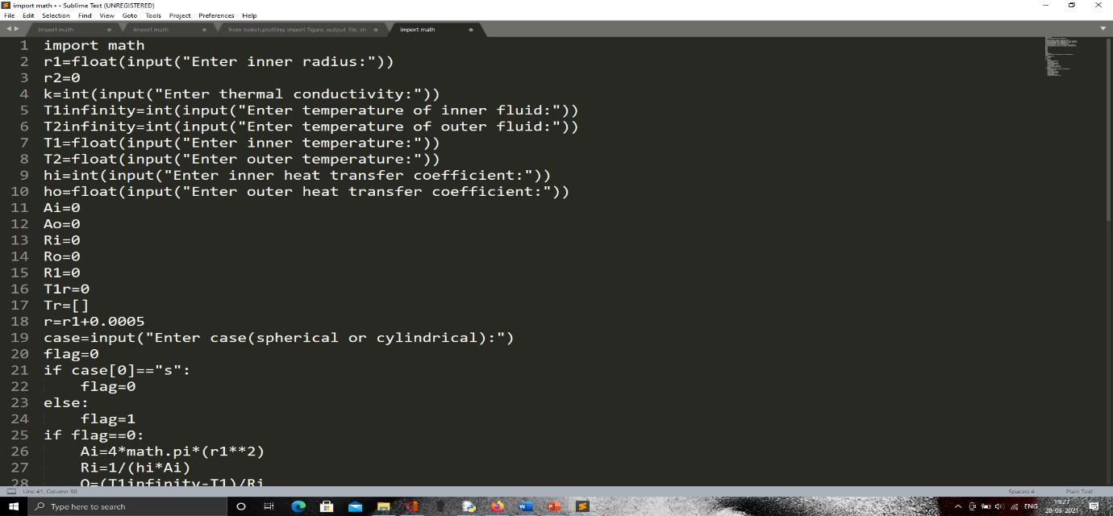

**Figure 4.7 (a)**

The code includes the design for both the spherical and the cylindrical reactor. The cylindrical reactor part requires the length of the reactor as well.

The second part of the code is given in the figure 4.7 (b) below,

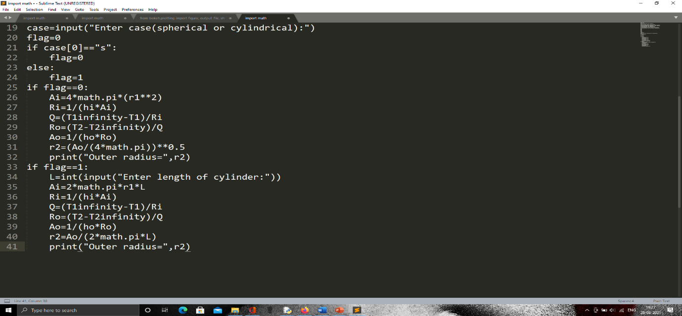

**Figure 4.7 (b)**

**4.4.1.1 Input and Output**

The input and output of the above code for the design of the spherical reactor is given in the figure below.

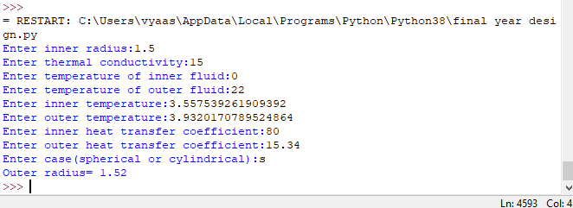

**Figure 4.7 (c)**

The input values are clearly seen and shown in black colour whereas all the text generated by the computer is given in blue.

We can clearly see that the outer radius of the designed reactor is blue in colour.

We can see that the value obtained is 1.52 which validates the design algorithm and the design code for the spherical reactor of the numerical problem.

**4.4.2 Design of Cylindrical Reactor**

For the design of the cylindrical reactor, we need an extra parameter called “L” which denotes the length of the reactor. We change the set of input variables and obtain a different set of output variables in comparison to the main problem code.

We make one of the input variables as an unknown and the output variable which was previously obtained would be one extra input similar to the design of the spherical rector.

We check if we get the same value of the initial input as the new output in the design program.

The initial input parameters were the inner and outer radius, inner and outer fluid temperature, inner and outer heat transfer coefficient, thermal conductivity.

The output includes the inner and outer surface temperatures and the thermal profile.

The input parameters for the design of the cylindrical reactor are the inner radius, inner and outer fluid temperature, inner and outer heat transfer coefficient, thermal conductivity and excludes the outer radius while including the inner or the outer surface temperatures.

The output includes the outer radius and the thermal profile.

The outer radius in this output is expected to be the same as the initial input of the outer radius in the main problem code.

The following is the code for the design of the cylindrical reactor.

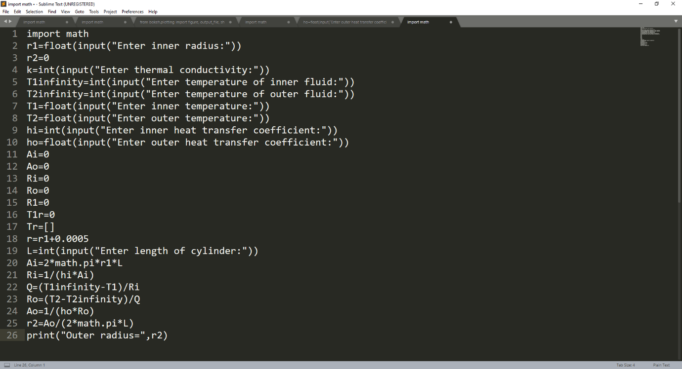

**Figure 4.7 (d)**

**4.4.2.1 Input and Output**

The input and output for the design computations of the cylindrical reactor has been given below. The computer-generated texts or prompts asking for input are shown un blue colour while the user input is shown in black colour. The user input is typed by the user and the values inputted is based on the main numerical problem taken from the guide.

For the design computations of a cylindrical reactor, we have an additional input parameter to include in the code and that parameter is “length of the cylinder.” For the length of the cylinder, we assume a certain value and the value has been assumed based on the similarity of the output compared to the spherical reactor. So, the input for the length of the cylinder is given as two meters and the raw input is “2” which is seen in the figure shown below.

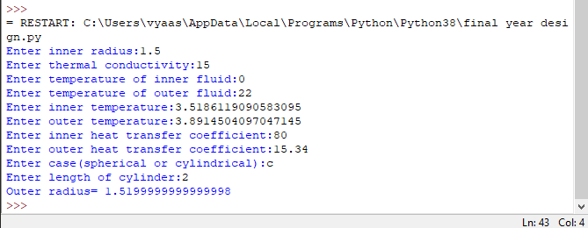

**Figure 4.7 (e)**

**4.4.3 Design of Spherical Reactor with Insulation:**

There are quite a few changes made for the design for the spherical reactor with insulation.

We try to do the similar thing by varying the input and output parameters and validate by comparing them.

We have a lot of new variables to be introduced and the code written for this purpose is screenshotted and given below,

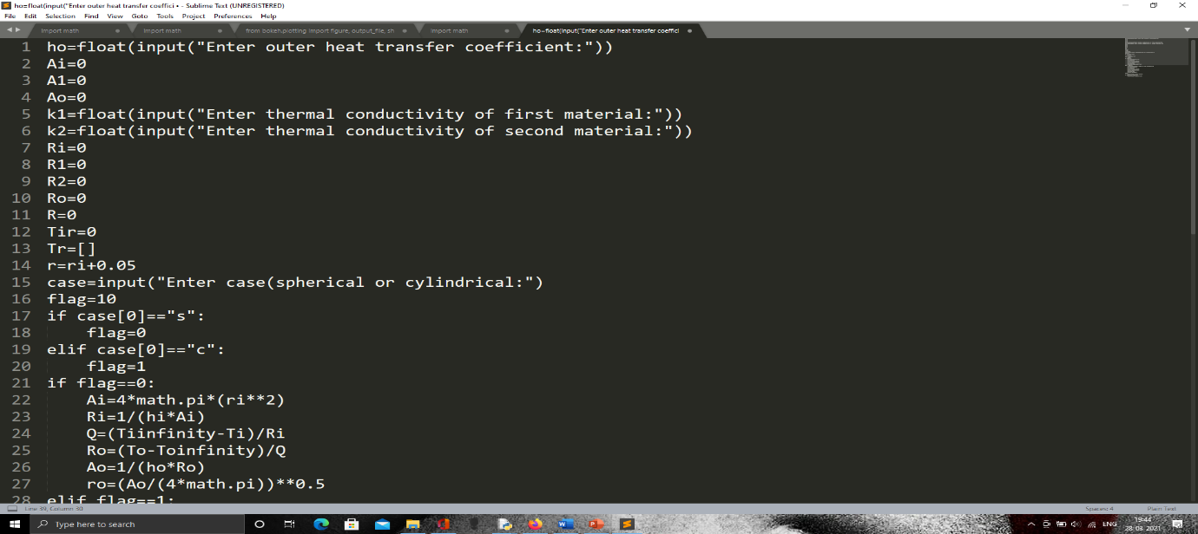

**Figure 4.7 (f)**

The second part of the code that contains the design in case of a cylinder is shown fully in the second screenshot of the code and it is given below,

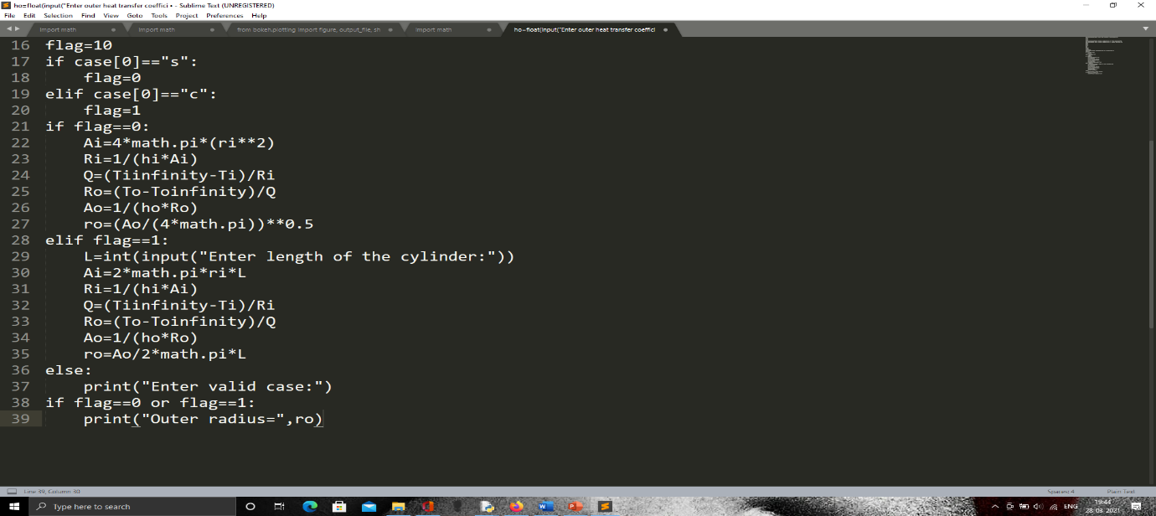

**Figure 4.7 (h)**

**4.4.3.1 Input and Output**

The input values are clearly seen and shown in black colour whereas all the text generated by the computer is given in blue.

We can clearly see that the outer radius of the designed reactor is blue in colour.

We can see that the value obtained is “1.529999999..” and is close to the value of “1.53” which validates the design algorithm and the design code for the spherical reactor with the insulation problem.

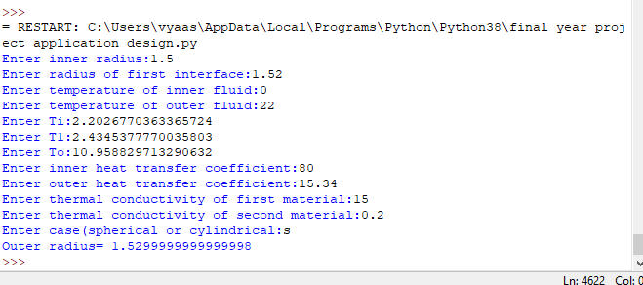

**CHAPTER 5**

**CONCLUSIONS**

**5.1 Conclusions**

1. The outer surface temperatures of the various mix compositions of RHX and RHFX where “X” ranges from 0-15 are “10.751281310656141, 11.001874356878297, 11.225309238175562, 11.665470463003514, 11.045452865244688, 11.179492781306998, 11.318712759509138, 11.824311789387176.”
2. The percentage change in the outer surface temperatures of the RHX where “X” ranges from 0 to 15 are “NIL, 2.33082029, 2.03088014, 3.921150104.”
3. The percentage change in the outer surface temperatures of the RHFX compositions where “X” ranges from 0-15 are “NIL, 1.213530289, 1.245315695, 4.466930477.”
4. The percentage change in the outer surface temperatures of RHX and RHFX for corresponding values of “X” from 0 to 15 are “2.736153451, 0.1467420735, 0.8320797169, 1.361636694.”

**REFERENCES**

1. A.N. Campbell∗, S.S.S. Cardoso, A.N. Hayhurst, “Oscillatory and non-oscillatory behaviour of a simple model for cool flames, Sal’nikov’s reaction, P→A→B, occurring in a spherical batch reactor with varying intensities of natural convection”, Combustion and flame, Volume154, Issues 1-2.
2. A.N. Campbell∗, S.S.S. Cardoso∗, A.N. Hayhurst, “A comparison of measured temperatures with those calculated numerically and analytically for an exothermic chemical reaction inside a spherical batch reactor with natural convection”, Chemical Engineering Science, Volume 62, Issue 11.
3. Bird, R. B., W. E. Steward, and E. N. Lightfoot, Transport Phenomena, p. 296, John Wiley, New York, 1960.
4. C. Toulouse, J. Cezerac, M. Cabassud, M.V. Le Lann and G. Casamatta- Optimisation and scale-up of batch chemical reactors: impact of safety constraints- -Chemical Engineering Science, Vol. 5l, No. 10, pp. 2243-2252, I996 Copyright © 1996 Elsevier Science Ltd Printed in Great Britain.
5. Chengping Chai, Charles J. Ammon, Monica Maceira, Robert B. Herrmann; Interactive Visualization of Complex Seismic Data and Models Using Bokeh. Seismological Research Letters 2018; 89 (2A): 668–676. doi: <https://doi.org/10.1785/0220170132>
6. David E. Kotecki and Richard A. Conti- Temperature distribution in an ideal azimuthally symmetric chemical-vapor-deposition reactor- Journal of vacuum science and technology.

doi: [10.1177/1420326x19862017](https://www.x-mol.com/paperRedirect/1368377975445807104)

1. Engineering ToolBox, “Emissivity coefficients materials”, 34 Engineering ToolBox, “Emissivity coefficients materials”, [www.engineeringtoolbox.com](http://www.engineeringtoolbox.com) , ac. 09/02/2019.
2. Engineering Toolbox, “Fluid Heat Transfer Coefficients - Heat Exchanger Surface Combinations”, url: <https://www.engineeringtoolbox.com/overall-heat-transfer-coefficients-d_284.html>
3. Engineering Toolbox, “Thermal Conductivities of some selected Materials and Gases”, url: <https://www.engineeringtoolbox.com/thermal-conductivity-d_429.html>
4. F. Shokrya, M. Abd Elfattaha, D.A. El-Gayarb, H.A. Faragb, G.H. Sedahmedb- Effect of drag reducing polymers and impeller geometry on the rate of mass and heat transfer at the wall of a cylindrical stirred tank reactor in relation to catalytic reactor design- Alexandria Engineering Journal Volume 59, Issue 1, February 2020
5. F.P. Incropera, A.S. Lavine, T.L. Bergman, D.P. DeWitt, Fundamentals of heat and mass transfer, John Wiley Sons, Hoboken (2007).
6. Fergus G. F. Gibb, Karl P. Travis, Neil A. McTaggart, David Burley & Kevin W. Hesketh- Modeling Temperature Distribution Around Very Deep Borehole Disposals of HLW- Nuclear Technology, Volume 163, Issue 1.
7. G.H. Sedahmed, Y.A. El-Taweel, M.H. Abdel-Aziz, H.M.El-Naqeara- Mass and heat transfer enhancement at the wall of cylindrical agitated vessel by turbulence promoters- Chemical Engineering and Processing: Process Intensification, Volume 80.
8. Guangyu Yang, Marjatta Louhi-Kultanen and Juha Kallas, “The CFD Simulation of Temperature Control in a Batch Mixing Tank- European Symposium on Computer Aided Process Engineering”, 13 A. Kraslawski and I. Turunen (Editors)
9. How can I draw a filled circle?”- Vatankhah on 13 Sep 2013, accepted answered by Walter Roberson- Mathworks- MATLAB answers- url: <https://in.mathworks.com/matlabcentral/answers/87111-how-can-i-draw-a-filled-circle>
10. How to plot concentric circles with a given set of radii”- asked by Bryce Thomas, answered by CT Zhu- StackOverflow- Matploitlib- url: https://matplotlib.org/stable/gallery/lines_bars_and_markers/multicolored_line.html
11. J. W. Ou and K. C. Cheng- Viscous dissipation effects on thermal entrance region heat transfer in pipes with uniform wall heat flux- Ou, J.W., Cheng, K.C.- “Viscous dissipation effects on thermal entrance region heat transfer in pipes with uniform wall heat flux.” Appl. Sci. Res. 28, 289–301
12. Jakob, M., Heat Transfer, Vol. 1, p. 451, John Wiley, New York, 1956.
13. Khamphee Jitchaiyaphum, Theerawat Sinsiri, Prinya Chindaprasirt,” Cellular Lightweight Concrete Containing Pozzolan Materials”, Procedia Engineering, Volume 14, 2011, Pages 1157-1164, ISSN 1877-7058.
14. Lennis Perez- “Material of construction options for chemical process plants”- url:<https://www.ddpsinc.com/blog-0/material-of-construction-options-for-chemical-process-plants>)
15. Mariusz Owczarek, “Parametric study of the method for determining the thermal diffusivity of building walls by measuring the temperature profile,” Energy and Buildings, Volume 203, 15 November 2019, 109426.
16. Matt J and Yuval , “How to plot six concentric circles using meshgrid and plot?”- asked by Yuval, accepted answer by Matt J- Mathworks- MATLAB answers- url: <https://in.mathworks.com/matlabcentral/answers/68765-how-to-plot-six-concentric-circles-using-meshgrid-and-plot>
17. Md Azree Othuman Mydin, “Effective thermal conductivity of foamcrete of different densities”, ISSR Journals Volume 2(1), March 2011.
18. Mingguang Zhang, Lei Ni, Juncheng Jiang, Wenxing Zhang- Thermal runaway and shortstopping of esterification in batch stirred reactors- Process Safety and Environmental Protection, Volume 111, October 2017.
19. Multicoloured Lines”- Matplotlib official website- matplotlib version 3.3.4- url: <https://matplotlib.org/stable/gallery/lines_bars_and_markers/multicolored_line.html>
20. Musa, Mohamad Nor, and Mohamed Fikhri Abdul Aziz. “Thermal Conductivity for Mixture of Rice Husk Fiber and Gypsum.” Applied Mechanics and Materials, vol. 819, Trans Tech Publications, Ltd., Jan. 2016, pp. 69–73. Crossref
21. NR Aravind, Dhanya Sathyanand K M Mini, “Rice husk incorporated foam concrete wall panels as a thermal insulating material in buildings”, Sage Journals, Volume 29, Issue 5,
22. P. Mishra, A. Chakraverty & H. D. Banerjee,” Studies on physical and thermal properties of rice husk related to its industrial application”, Journal of Materials Science, P. H. G. da Silva, J. Moreira, A. O. S. Costa, E. F. Costa Jr., “Numerical analysis of the thermal profile inside the wall of a rotary cement kiln”, Cerâmica vol.66 no.380 São Paulo Oct./Dec. 2020, E-pub Oct 30 2020.
23. Plotting graph with different colours in python”- asked by bandito40, answered by Juilen Spronck- StackOverflow- Python/Matplotlib/multicoloured line- url: <https://stackoverflow.com/questions/35372993/python-matplotlib-multicolor-line>
24. Python Heat Distribution Plotting”- asked by T. Oguz, answered by Sheldore- StackOverflow- url: https://stackoverflow.com/questions/54833089/python-heat-distribution-plotting
25. R. M. da Silva, Antonio Gilson Barbosa de Lima, A. S. Pereira, M. C. N. Machado, R. S. Santos- Unsteady State Heat Transfer in Packed-Bed Elliptic Cylindrical Reactor: Theory, Advanced Modeling and Applications- Transport Phenomena in multi-phase systems.
26. Rahul Kooragayala- Temperature Simulation and Heat Exchange in a Batch Reactor Using Ansys Fluent- West Virginia University, Research Repository.
27. Ramazan Demirboǧa, Rüstem Gül, “Thermal conductivity and compressive strength of expanded perlite aggregate concrete with mineral admixtures”, Energy and Buildings, Volume 35, Issue 11, 2003, Pages 1155-1159, ISSN 0378-7788.
28. S. K. A. Fahad and A. E. Yahya, "Big Data Visualization: Allotting by R and Python with GUI Tools," 2018 International Conference on Smart Computing and Electronic Enterprise (ICSCEE), Shah Alam, Malaysia, 2018, pp. 1-8, doi: 10.1109/ICSCEE.2018.8538413. (circle)
29. S. Malathi, N. S. Bhuvaneswari, “Control Strategy of Glass-Lined Batch Polymerization Reactor for PVC Resin Industrial Process”, International Journal of Applied Engineering Research ISSN 0973-4562 Volume 13, Number 17 (2018) pp. 13392-13401 © Research India Publications. <http://www.ripublication.com>
30. Stéphane Hattou, Marie-Véronique Le Lann, Karlheinz Preus, Boris Roussel, Michel Cabassud, “Implementation of model predictive controller in a pharmaceutical development plant”, 21st European Symposium on Computer Aided Process Engineering – ESCAPE 21 E.N. Pistikopoulos, M.C. Georgiadis and A.C. Kokossis (Editors) © 2011 Elsevier B.V.
31. The editors of Encyclopaedia Britannica- “Heat Transfer”, Encyclopædia Britannica (2019) [www.britannica.com](http://www.britannica.com).
32. Theodora Adamopouloua, MariaI Papadakia, Manolis Kounalakisa,Victor Vazquez-Carretob, Alba Pineda-Solanob, Qingsheng Wang, M. Sam Mannan, “Thermal decomposition of hydroxylamine: Isoperibolic calorimetric measurements at different conditions”, Journal of Hazardous Materials, journal homepage:www.elsevier.com/locate/jhazmat
33. Viron Gil Estrada and Star Strider , “How to plot solid concentric circles in a meshgrid?”- on 14 Mar 2018, answered by Star Strider- Mathworks- MATLAB answers- url: <https://in.mathworks.com/matlabcentral/answers/388287-how-to-plot-solid-concentric-circles-in-a-meshgrid>
34. Xiaoying Shana, David P. Schmidtb, James J. Watkins- Study of natural convection in supercritical CO2cold wall reactors: Simulations and experiments- The journal of supercritical fluids, Volume 40, Issue 1.
35. Yongjiang Wang, Li Pang, Xinyu Liu, Yuansheng Wang, Kexun Zhou, Fei Luo, “Using thermal balance model to determine optimal reactor volume and insulation material needed in a laboratory-scale composting reactor,” Bioresource Technology, Volume 206, 2016, Pages 164-172, ISSN 0960-8524.
36. Yunus A. Cengel, Afshin J. Ghajar, “Heat and Mass Transfer, fundamentals and applications”, 5th Edition with S.I units, pg.125-166.